**Evolution**: the change in the frequency of types from one generation to the next. Biological evolution is the change in allele frequencies within a gene pool.

**Exponential growth (Malthusian law)**

**Discrete model**

Consider dividing cells in discrete generations t and let $x_{t}$ be the number of cells in generation t. The difference equation $x_{t+1 }= 2x_{t}$ has the solution $x_{t} = x_{0}2^{t}$

**Continuous model**

Consider continuous time t and let x(t) be the continuous number (fraction) of cells at time t. Assume that **the generation time** T is exponentially distributed with average $\frac{1}{r}$, i.e., $Prob\left(T≤τ\right)=1-e^{-rτ}$. The differential equation $x^{'}=\frac{dx}{dt}=rx$ has the solution

$x(t) = x_{0} e^{rt}$, where r is the rate of cell division

**Logistic growth**

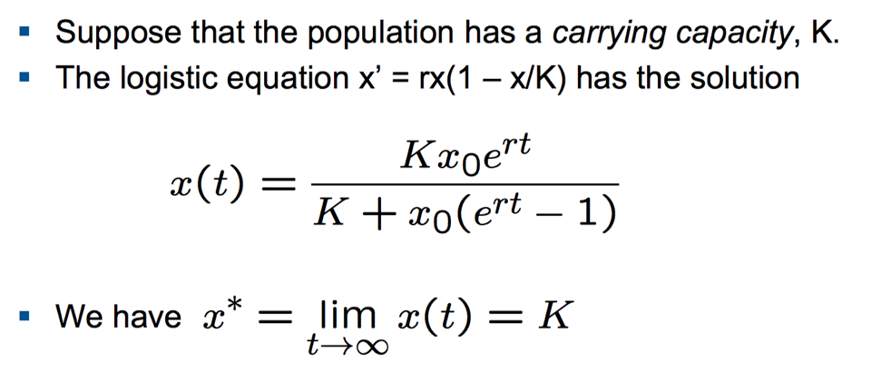

**The logistic difference equation**

After rescaling, assume K = 1. Then $x_{t+1}=ax_{t}(1-x_{t})$

The growth rate, a, corresponds to r in the logistic differential equation

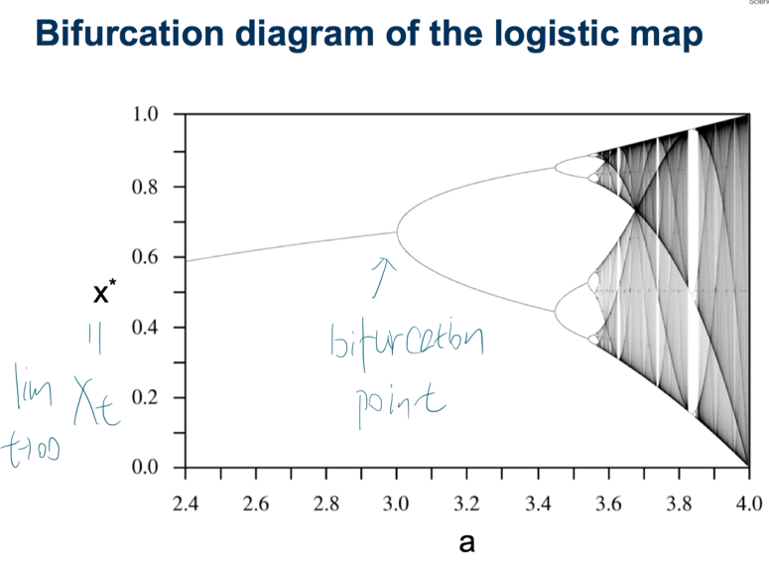

For a = 4, the equation produces a deterministic chaos.

**Cell death**

Suppose that cells have an average life span of 1/d. The differential equation becomes $x’ = (r – d) x$. The quantity $R_{0} = r/d$ **is called the basic reproductive ratio**. It denotes the expected number of offspring from a single individual. If $R_{0}>1,$ the population expands indefinitely; If $R_{0}<1,$ the population goes extinct. If $R_{0} = 1$, then the population size remains constant

**Selection**: the result of different growth rates associated with different types of individuals.

The **fitness** of an individual is its relative growth rate.

**For two independent exponentially growing types**, the type with higher growth rate would be dominant but neither type go extinct.

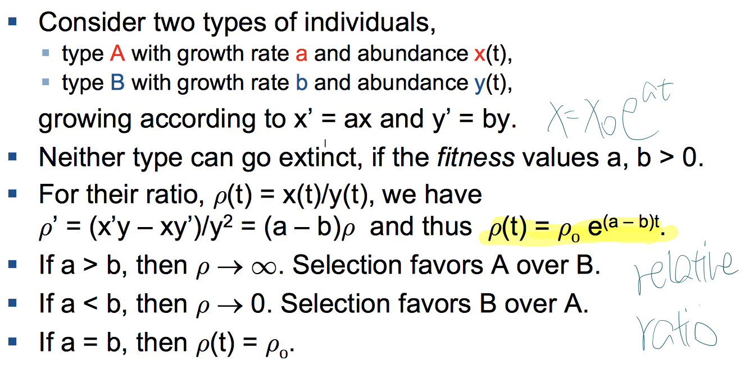

**For competing types**

**Subexponential and superexponential growth**

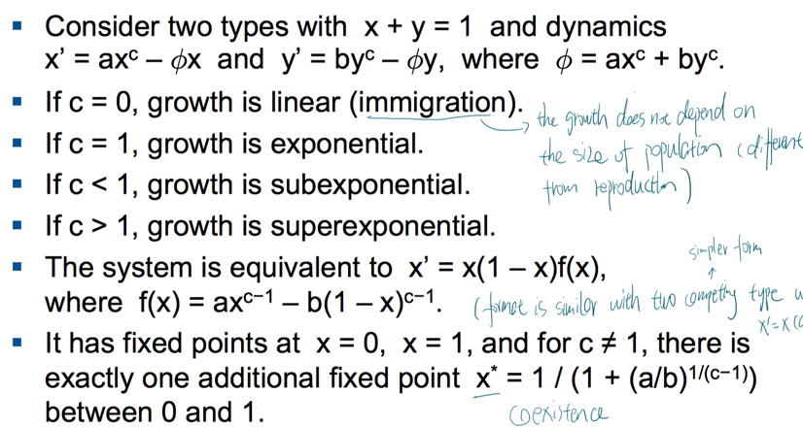

**C=1, survival of the fitter.**

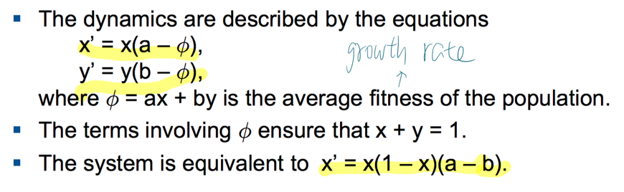

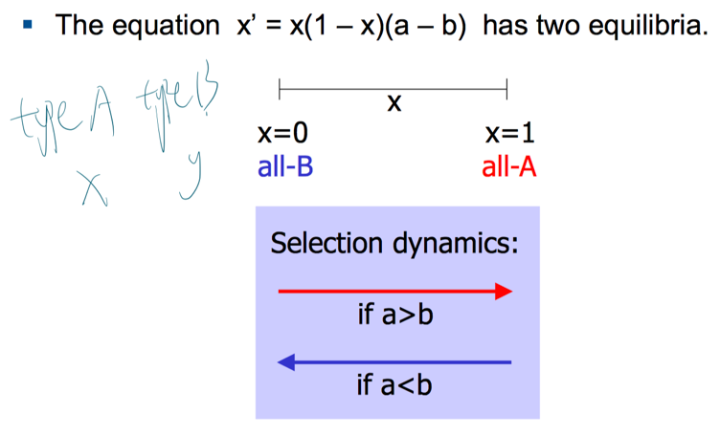

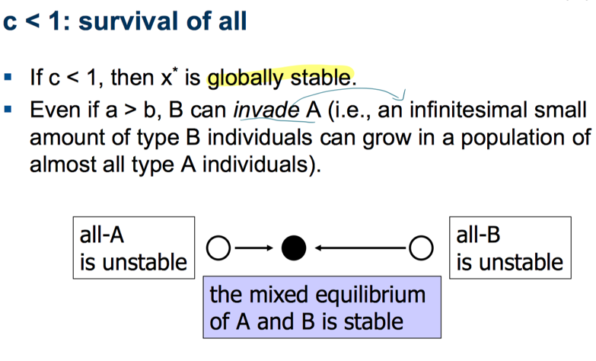

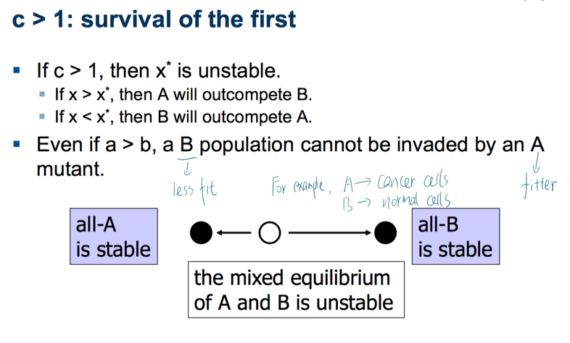

**Expansion from 2 to n types in exponential growth model**: 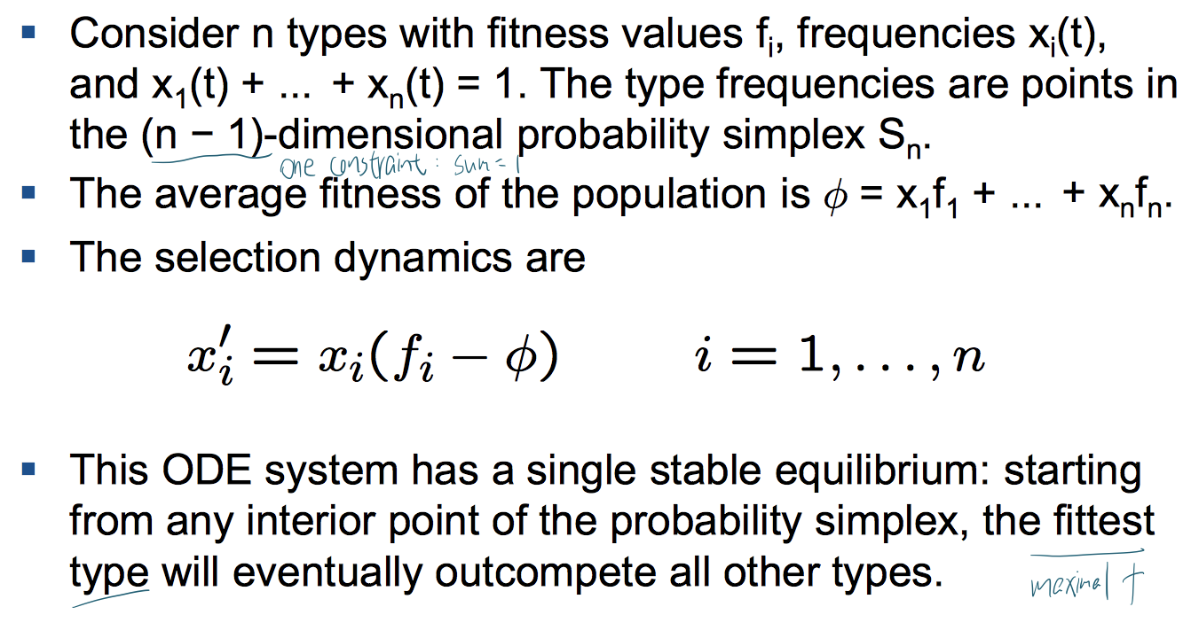

**Mutation**: during reproduction (cell division )/ without reproduction (radiation)

**Basic mutation dynamics** (no selection => assume two types of equal fitness a = b = 1)

Suppose that mutation rates $u_{1} = Prob(A→ B) and u_{2} = Prob(B→A)$ during reproduction.

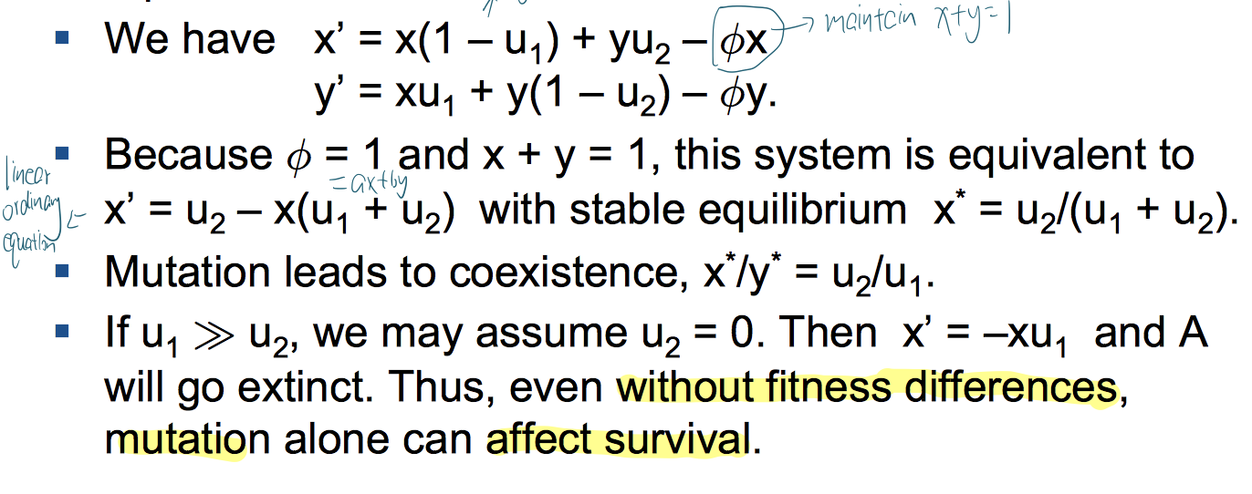

**Expansion from 2 to n types**

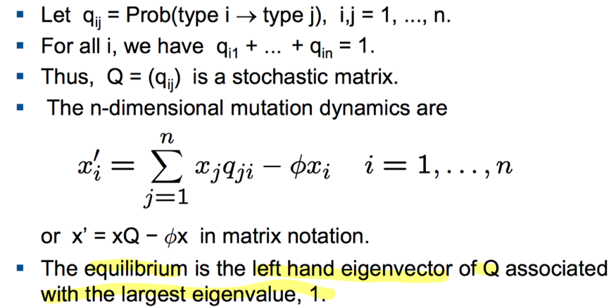

**Hardy-Weinberg principle**: states that allele and genotype frequencies in a population will remain constant from generation to generation in the absence of other evolutionary influences.

**Sequence space**

Sequence space $A^{L}$ has dimension L, and consists of ${\left|A\right|}^{L}$ sequences. Distance is measured by the Hamming distance. In this metric, all sequences are close to each other: the distance between any pair of sequences is bounded by L. The genotype space is subset $G ⊂A^{*}$.

**Fitness landscapes**

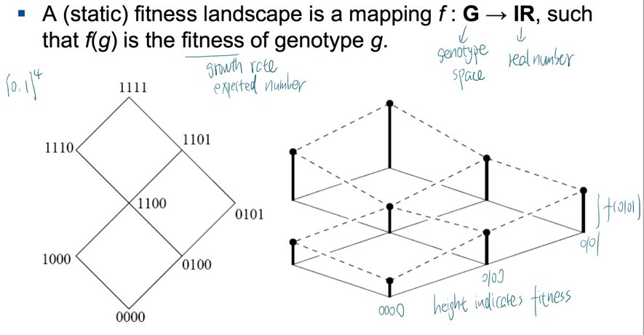

**Binary sequence**

Consider binary sequences of fixed length L. We assume that only point mutations occur in this population (ignoring insertion, deletions, recombination) and that they are independent and occur at the same rate u.

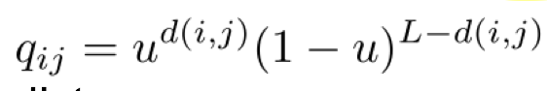 where $d\left(i,j\right)$ is hamming distance between genotype i and j

Epistatic interactions (Epistasis is the phenomenon wherein the effect of one gene (locus) is dependent on the presence of one or more 'modifier genes')

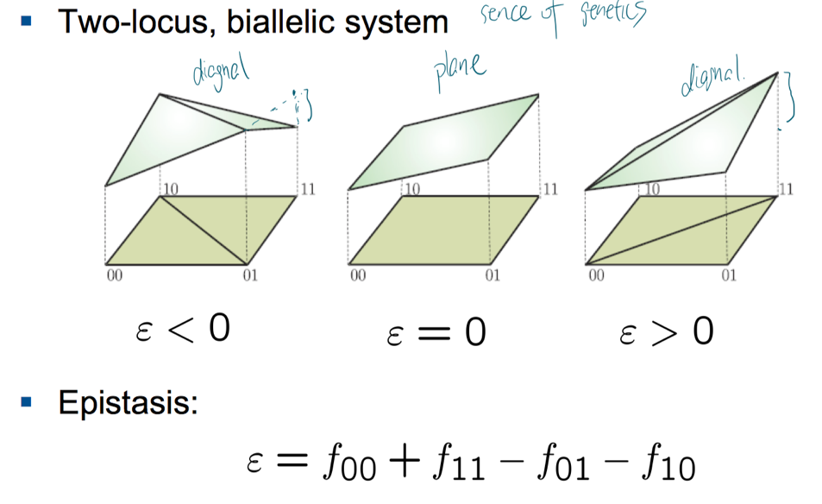

More precisely, f : G → P → IR because fitness depends on the phenotype of the organism. But phenotype space is more complex and less well defined. Besides, in general, fitness depends on how the individual interacts with the ecological environment and with other individuals in the population. By now we assume fitness only depends on genotype.

**The quasispecies equation** (species refers to chemical species)

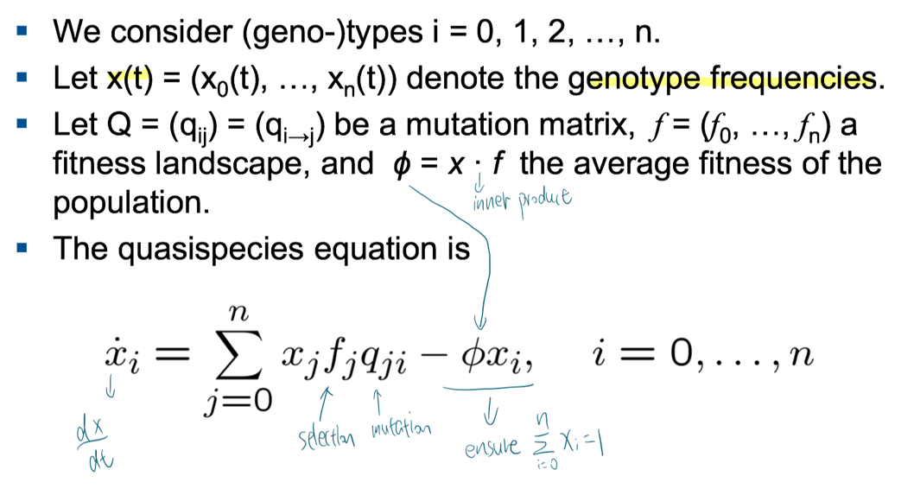

When Q = I, it means no mutation, then we recover the selection equation (“survival of the fittest”).

When f = (1,…,1), it means no selection, then we recover the mutation equation.

If Q is irreducible, there is a single, globally stable equilibrium x * in the interior of the probability simplex. It means no type goes extinct

**Solving the quasispecies equation**

1. Suppose $ψ\left(t\right)= \int_{0}^{t}{ϕ(s)ds}$, then $X =\sum_{j=0}^{n}{X_{j}=e^{ψ}}$ and $\dot{X}=\dot{ψ}e^{ψ}=ϕX$??

The total population size X grows exponentially at rate $ϕ$

1. With the mutation-selection matrix $W =\left(w_{ij}\right)=(f_{j}q_{ji})$, the quasispecies equation can be written as

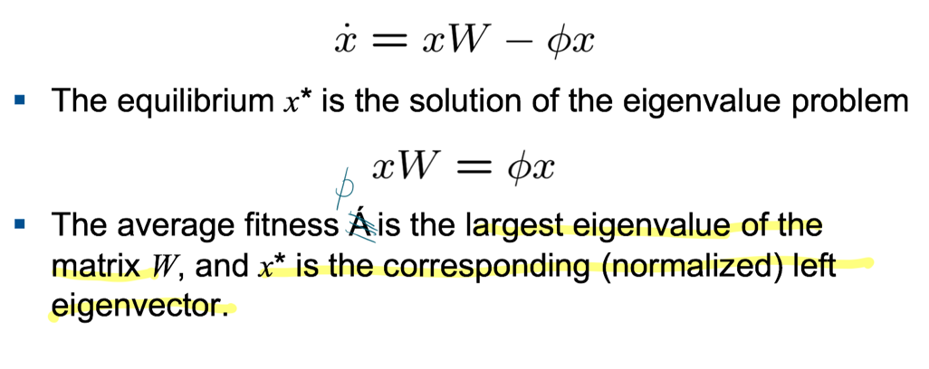

**Adaptation of a quasispecie**

**Adaptation** of a population is localization in sequence space at a (local) maximum of the fitness landscape.

Interpretation of equilibrium $x^{*}$ of the quasispecies equation: **a mutation-selection balance of the population: selection drives individuals towards a local peak of the fitness landscape, while mutation generates types of lower fitness.**

**Condition for adaptation**: Adaptation is no longer possible if mutation removes the fittest types faster than they are selected (high mutton rate). There should be a necessary condition on the mutation rate and the selection strength for adaptation to occur. This condition is called the error threshold, and it exists for many, but not all, fitness landscapes.

Example

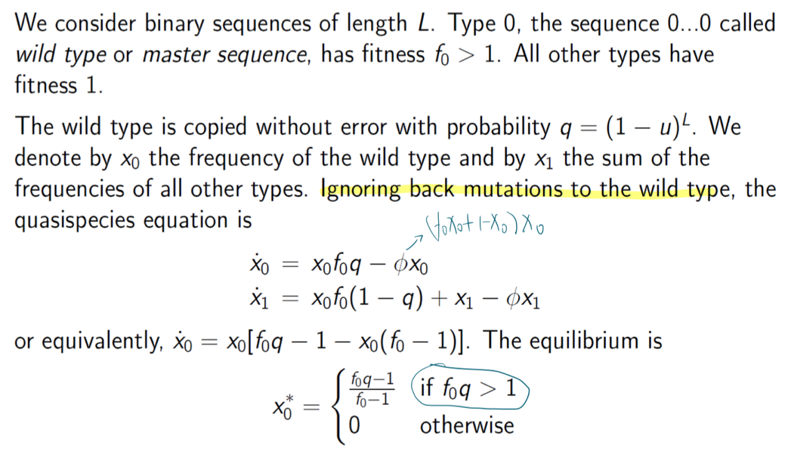

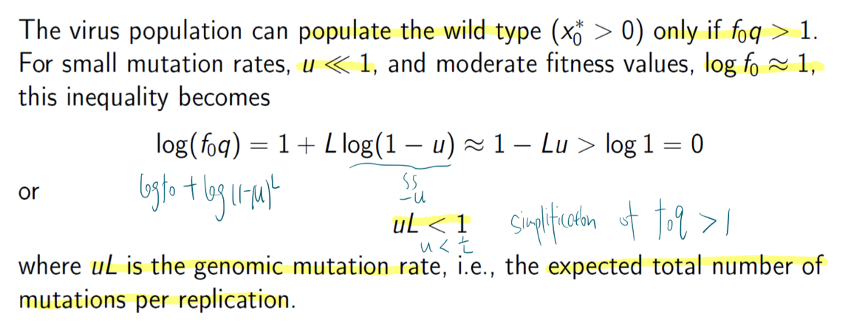

Therefore, the adaption only occurs below the critical mutation rate $u_{c}=\frac{1}{L}$, the error threshold. For longer genome, lower mutation rate is required to allow the wild (fittest) type adaptation.

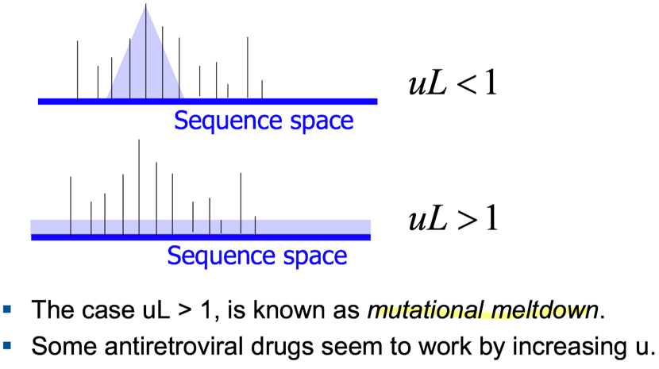

**The exponential distribution**

A continuous random variable X is exponentially distributed with parameter $λ$ > 0

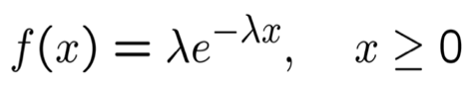

density function

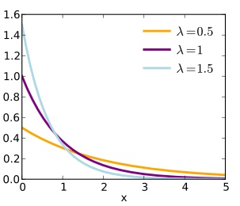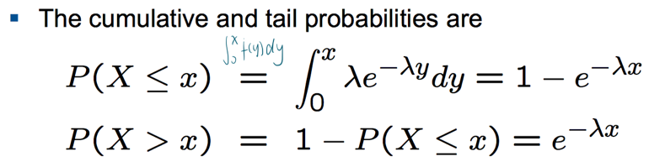

$E\left(X\right)=\frac{1}{λ} V\left(X\right)=\frac{1}{λ^{2}}$

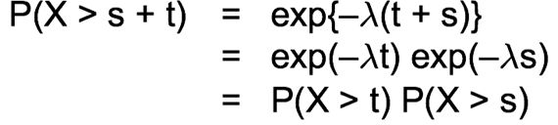Memoryless

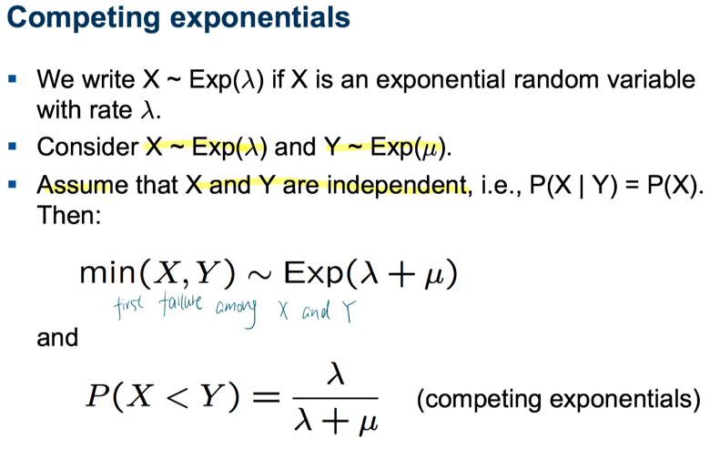

**Markov chains**

.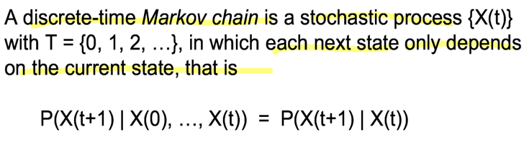 Transition matrix P of a Markov chain {X(t)} is defined by

$P_{ij}\left(t\right)=P\left(X\left(t+1\right)=j\right|X\left(t\right)=i)$

The Markov chain is **time-homogeneous** if $P_{ij}$ does not depend on t for all i and j. A state x* is an absorbing state if X(t) = x* for all $t≥t_{0}$.

A Markov chain is ergodic if it is

1) aperiodic (return to any state is always possible),

2) irreducible (any state is accessible from any other), and

3) positive recurrent (any state will eventually be reached with probability 1 and the mean recurrence time is finite).

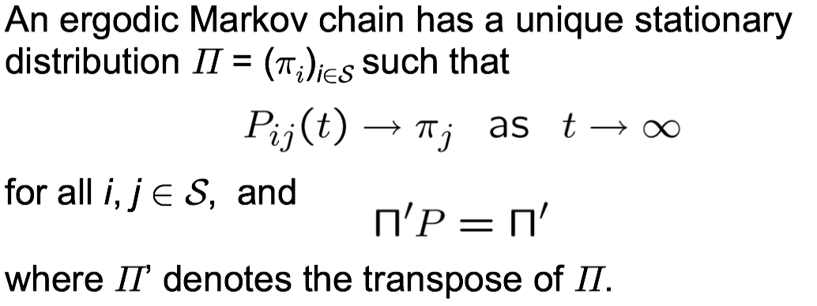where $Π^{'}=[π_{1},…, π_{n}]$

**The Moran process**

Suppose a finite population of constant size N with individuals of two types, A and B.

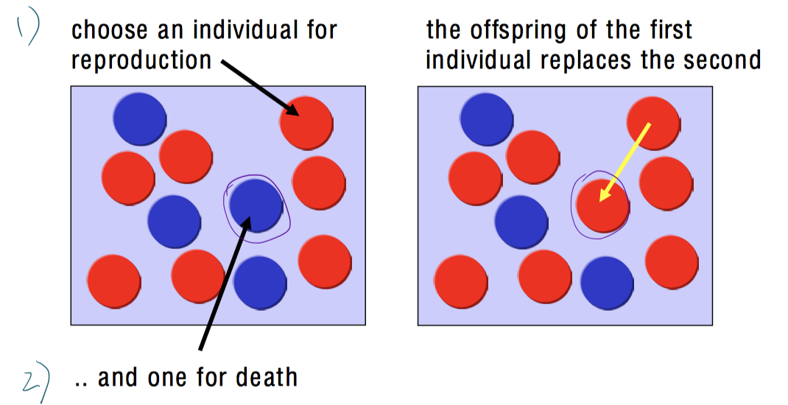

1. It defines a discrete Markov chain

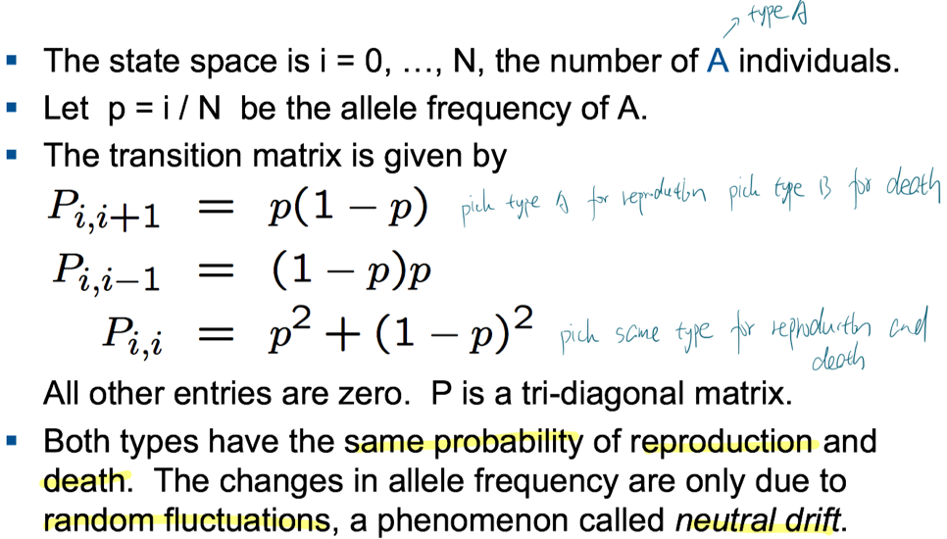

Absorbing states (No way to escape from the current state): 1. Fixation, all A ( $P_{N,N}=1, P_{N,i}=0 for i<N)$ 2. Extinction, All B ($P_{0,0}=1, P_{0,i}=0 for i>0$)

1. It is a birth-death process

the number of A individuals can change only by one in each step. A stochastic process with this property is called a birth-death process.

**Fixation probabilities**

Let $x_{i}$ be the probability of ending up in state N when starting from state i.

For the simple neutral Moran process this probability is $x_{i}=\frac{i}{N}$

Since all individuals have the same fitness, they also have the same chance of becoming the ancestor of the whole population.

The mean fixation time (how to compute ??)

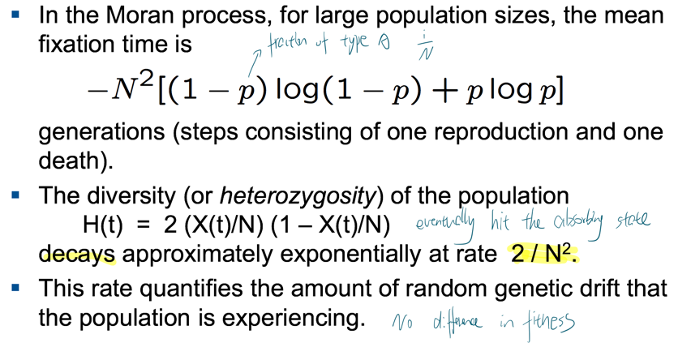

When fitness of different types is different (selection)

This can be incorporated into the model if individuals with allele A have fitness $f_{i}$ and individuals with allele B have fitness $g_{i}$. Suppose $α_{i}=P_{i,i+1} , β_{i}=P_{i,i-1}, y_{i}=x_{i}-x_{i-1}$

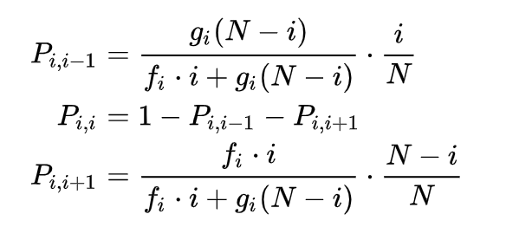

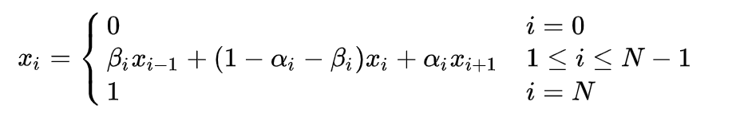

Since $x_{i} =β_{i}x_{i-1}+α_{i}x_{i+1}+\left(1-α_{i}-β_{i}\right)x_{i}$

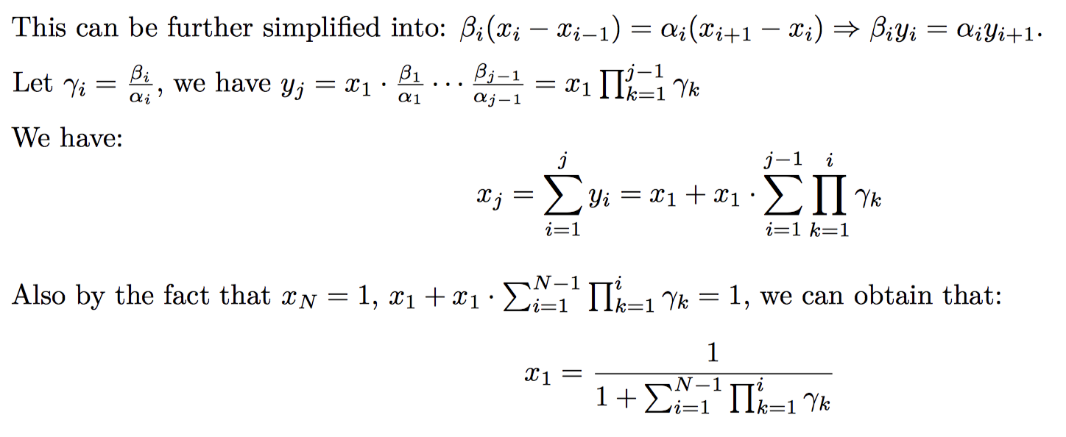

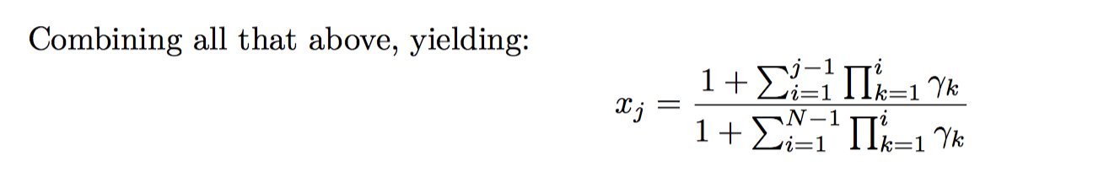

When the selection is constant

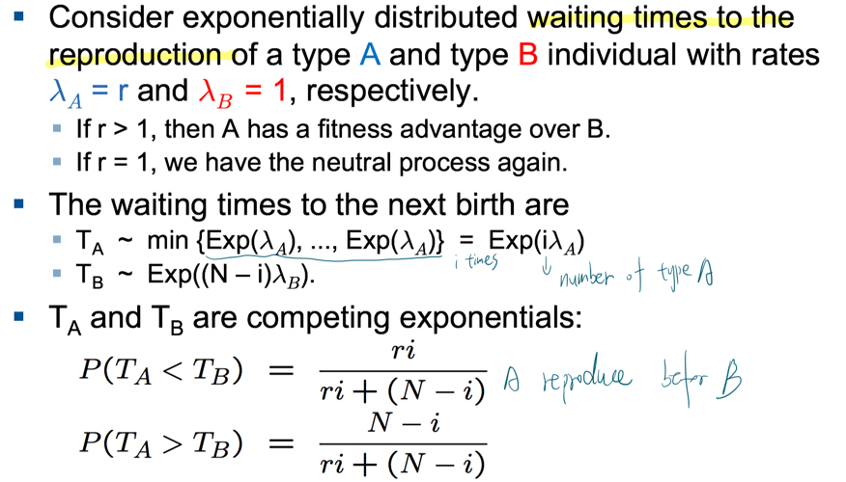

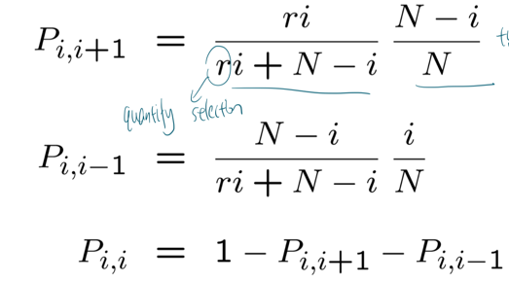

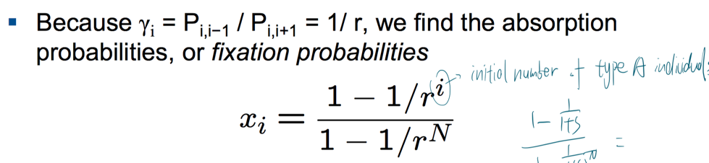

**Poisson process**

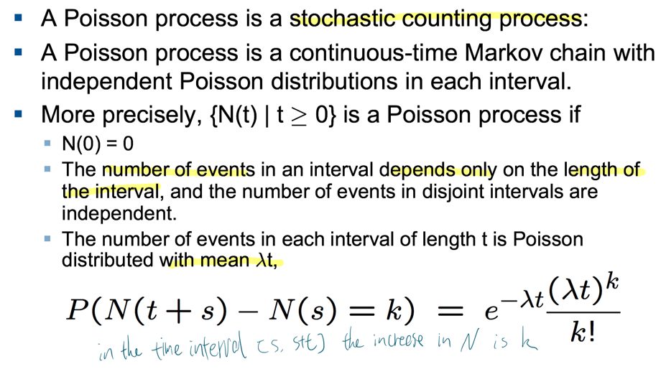

Inter-arrival times of a Poisson process are exponential

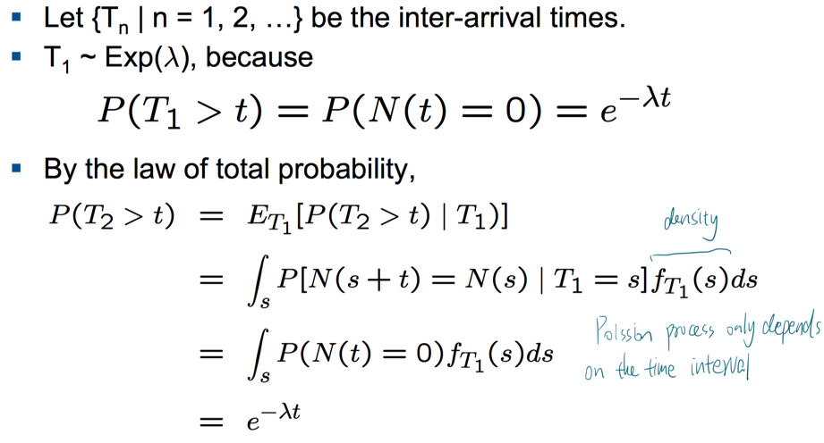

**The rate of evolution**

Consider an all-A population where a B mutant occurs rarely at mutation rate u.

The Poisson process is a good model for counting the mutations. In particular, $T_{1} \sim Exp(Nu)$

Suppose that type B has a selective advantage r. Then the fixation probability is $ρ= x_{1}$

The rate of evolution from all-A to all-B is $R =Nuρ$??

The probability that a mutant B has been fixed by time t is $1-e^{-Rt}$

If B is neutral, then $ρ$ = 1/N and R = u, the mutation rate.

If u is constant, then neutral mutations accumulate at a constant rate R = u, independent of population size. In this way we can determine the time scale of this process (molecular clock).

**Cancer**

The rate of activating oncogenes and inactivating TSGs depends on population size, mutation rates, and fitness**.**

Tissue architecture (small compartments )can affect the rate of evolution of **cancer.** The linear process delays cancer initiation.

**Oncogene**: increase fitness if one allele is mutated or inappropriately expressed. They are activated by 1. Point mutation 2. Amplification 3. Chromosome fusion

1. **Fixation of oncogene mutations**

Consider a Moran process in a compartment with effective population size N

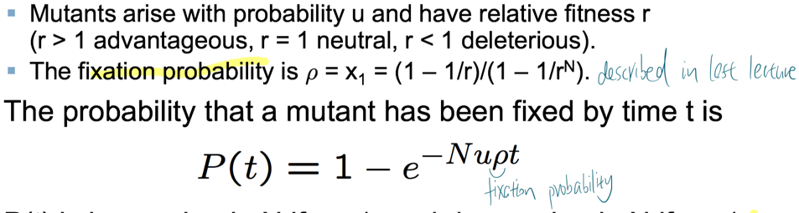

P(t) is increasing in N if r > 1, and decreasing in N if r < 1.

**Influence**: Large compartments accelerate the accumulation of advantageous mutations, small compartments slow it down. Most tissues with high cell turnover are organized in many small compartments.

1. **The linear process of cancer**

A mutant with relative fitness difference r has fixation probability $ρ=\frac{1}{N}$, because only a mutation in the left most stem cell leads to fixation, which means only the location could impact the chance of becoming the ancestor for the population instead of fitness

Therefore, the probability that the mutant has taken over by time t is $P\left(t\right)=1-e^{-ut}$ and independent of r

**Influence**: Delays advantageous mutations. In contrast to well-mixed populations, where advantageous mutations accumulate faster, all types of mutations (advantageous, neutral, or deleterious) have the same fixation probability in the linear process

**Tumor suppressor genes:** somatic mutations in TSGs are recessive: inactivation of one allele is (nearly) neutral, while inactivating the second allele confers a fitness advantage. TSGs are inactivated by 1. Point mutation 2. one point mutation followed by loss of heterozygosity (LOH)

1. **For neutral mutation, type 1 cells reach fixation before a type 2 cell arises in small compartments**

The average fixation time of the first mutation is $1/ρ$ = N ( $ρ$ is the fixation probability) in the Moran process. The average waiting time for the second mutation (in any teach occurrence not cell) is $\frac{1}{Nμ_{2}}$. (??)

So, type 1 cells reach fixation before a type 2 cell arises, if $N≪ \frac{1}{Nμ_{2}}=>N≪1/√μ_{2}$ (small compartments)

**Three-state ODE model**

the dynamics can be described by the probabilities $X_{i}(t)$ of being in the three states i = 0, 1, 2. State 0: all cells are of type 0 ; State 1: all cells are of type 1; State 2: at least one cell is of type 2

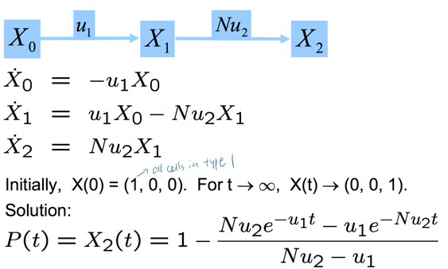

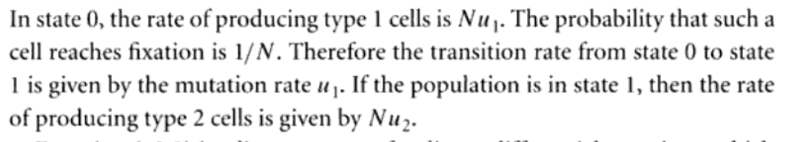

**Three time scales**

1. 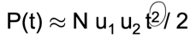When $t≪\frac{1}{Nu_{2}}$

there are two rate limiting events

1. When $\frac{1}{Nμ_{2}}<t<\frac{1}{u_{1}}, P\left(t\right)≈1-e^{-u_{1}t}$

On this time scale, the second hit is fast and can be

Neglected, only the first hit is rate limiting.

1. For very long times (beyond human life time), t >> $\frac{1}{u_{1}}$,

there are no rate limiting events.

**For intermediate population size**

The average waiting time for a type 1 cell is $\frac{1}{Nu_{1}}$, which is long if N < $1/u_{1}$

A type 2 cell is generated before fixation of the type 1 lineage, if N > $1/√u_{2}$.

Thus, type 1 is “tunneled” in the intermediate regime (population tunnels from state 2 to state 0 without reaching state 1).

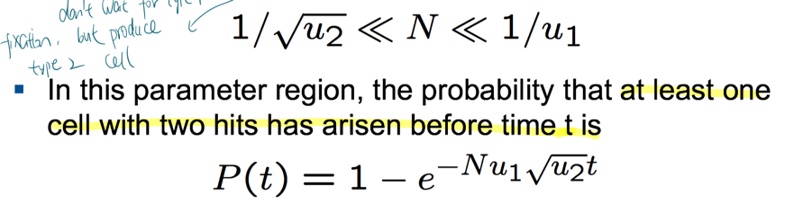??

For large population size

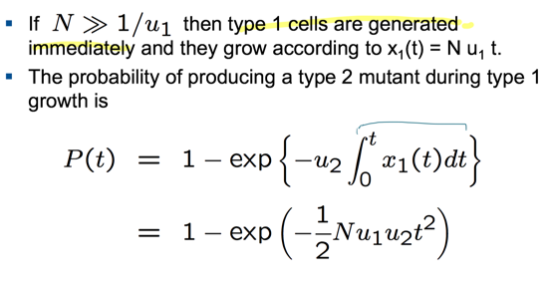 ??

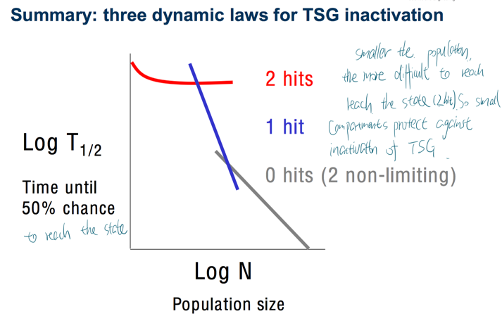

Genetic instability

Microsatellite instability: caused by mutations in mismatch repair genes; increases the point mutation rate

Chromosomal instability: increased rate of gaining or losing whole chromosomes or large parts of it

TSG inactivation with and without CIN

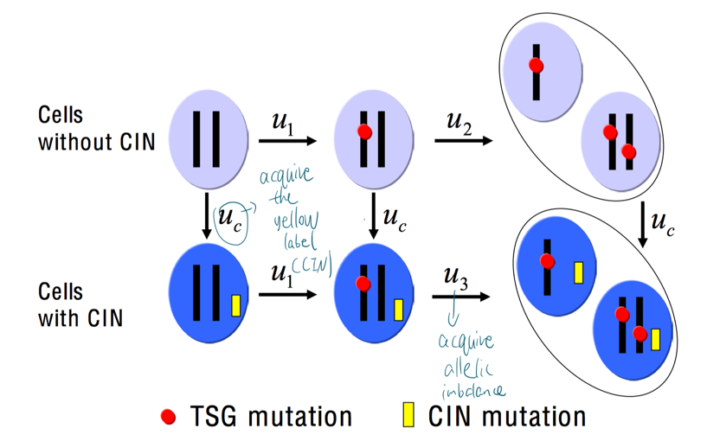

For small compartments, $N≪ 1/u_{1} , 1/u_{2} , 1/u_{c}$, we consider the corresponding homogeneous states

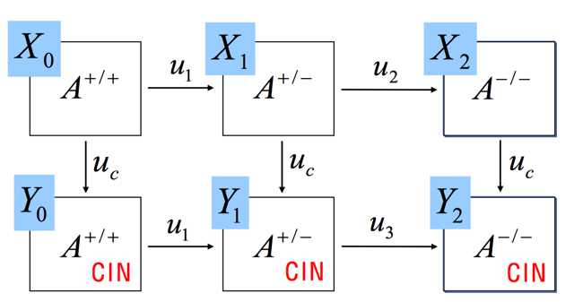

For Neutral CIN in small compartments

Suppose CIN and A +/– are neutral ( $ρ$ = 1/N), and that A –/– will be fixed immediately ( $ρ$ = 1).

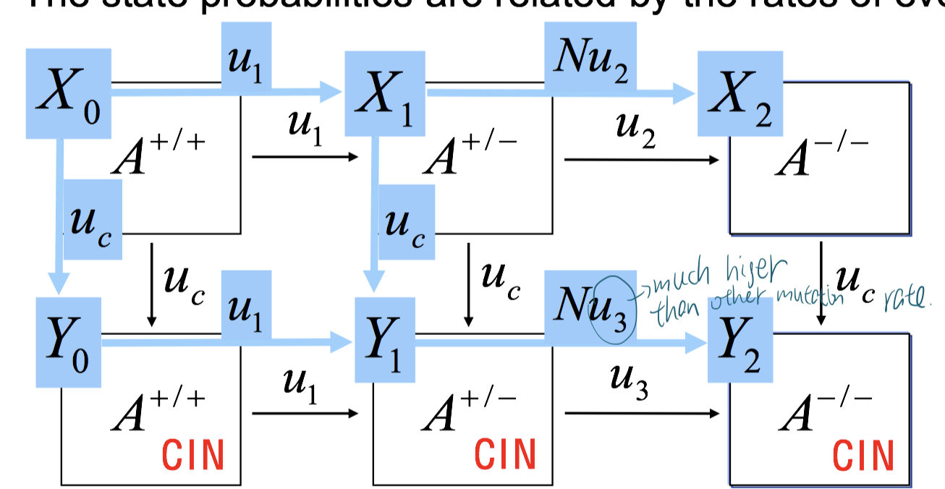

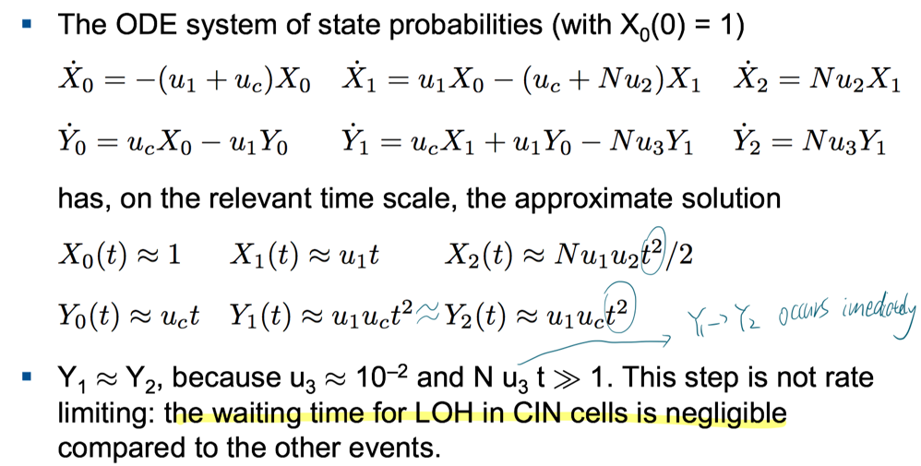

For costly CIN in small compartments

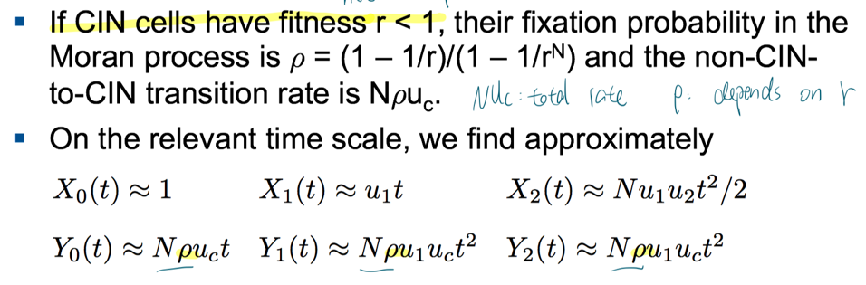

Costly CIN in large compartments

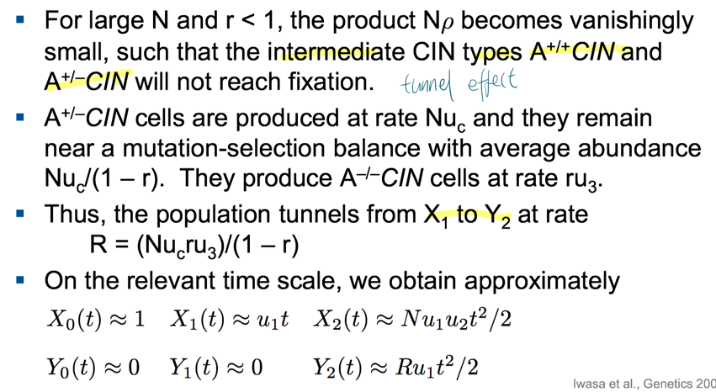

**Cancer progression**

**Multistage theory** (rate of incidence and time is log-log linear relationship)

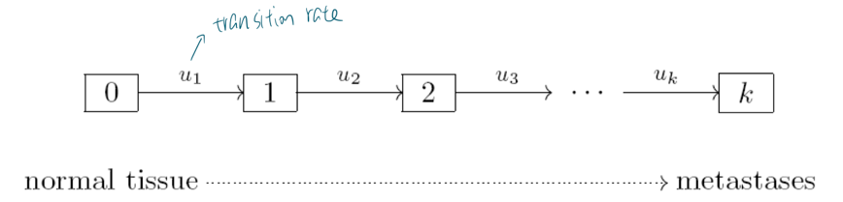

If $u_{j}=u$ is small, Prob (one step by t) = $1-e^{-ut} ≈ut$. The incidence (rate) is

$I_{k}\left(t\right)={\left(ut\right)}^{k-1}u=u^{k}t^{j-1}$ =>

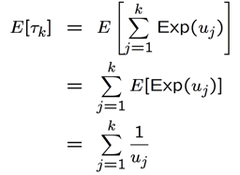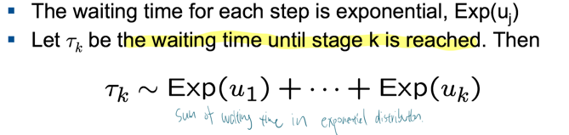

The mutational landscape of colon cancer: few mountains (In each patient, 15 to 20 mutated genes seem to drive progression. This set of genes differs considerably among patients.), many hills

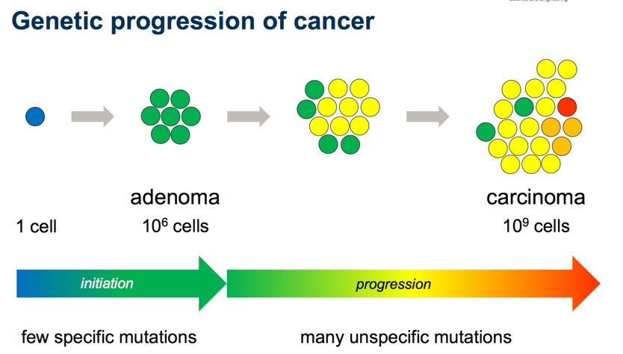

Independent mutations

Each mutation occurs independently at time $T_{j}\sim Exp(λ_{j})$ (different from transition rate u)

Waiting time to any k independent mutations

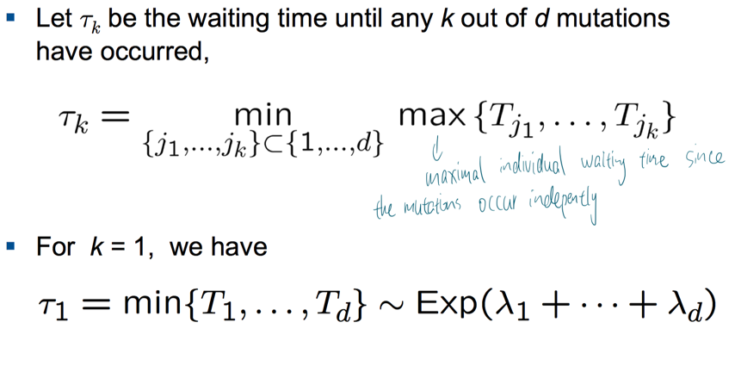

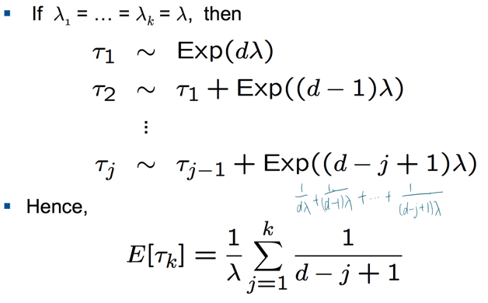

Each total order of mutations $j_{1}<…<j_{k}$ defines a mutational pathway in the genotype lattice. For a fixed path, let $Exit_{i}$ denote the set of all possible mutations in step i.

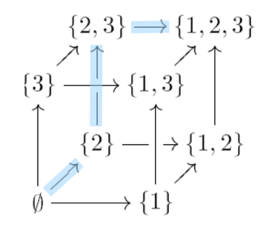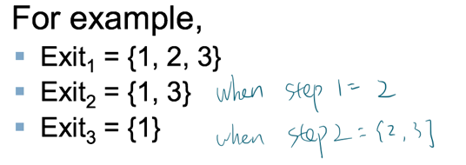

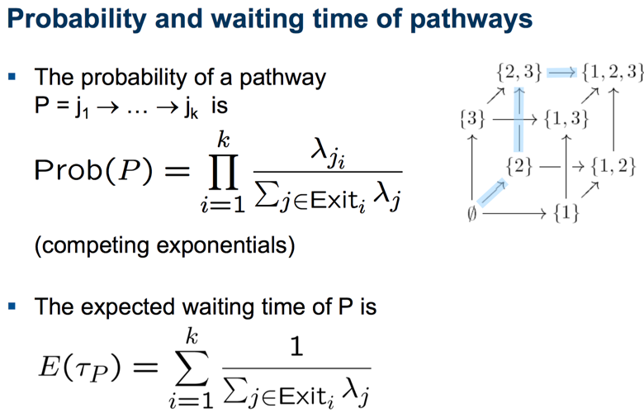

**Waiting time to cancer**

$$E\left(τ_{k}\right)=\sum_{path}{P(path)E(τ_{path})}$$

**The Wright-Fisher process** (a stochastic process that describes the evolution of an asexual)

1. It defines a Markov chain

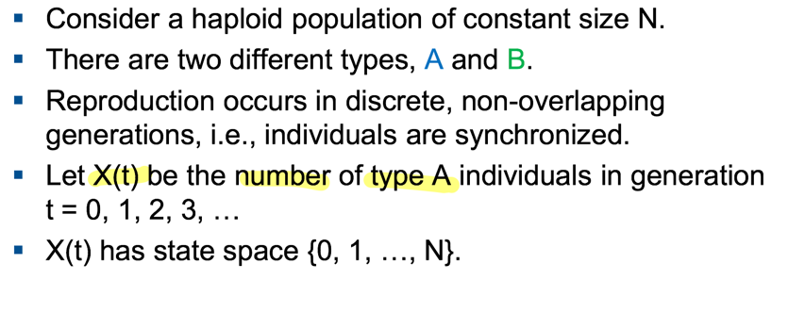

1. Choose parents from the previous generation randomly (Binomial sampling)

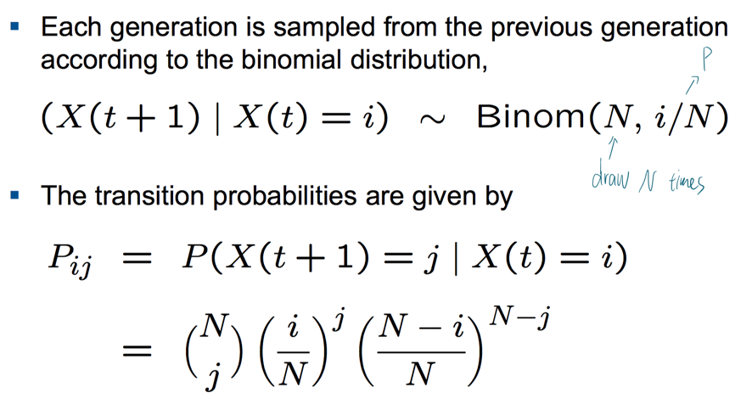

1. Properties of Neutral WF process (Proof in ex5)

Mean: The Wright-Fisher process is unbiased: the average frequency of type A individuals does not change over time, namely $E\left[X\left(t\right)\right]=i$ for all t = 0, 1, 2, …

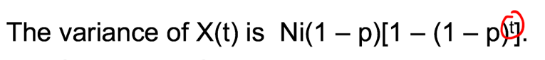

Variance:

Fixation probability: $x_{i}=\frac{i}{N}$

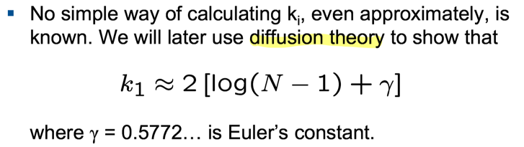

Mean fixation times:

**Wright-Fisher process for accumulating mutations**

Assume that each locus (independently) undergoes mutation from 0 to 1 at rate u. We ignore back mutations from 1 to 0. A constant fitness advantage, s, per mutation.

Let $X_{j} \left(t\right)$ be the number of cells with j mutations (called j-cells) in generation t. The fitness of a j-cell is proportional to ${\left(1 + s\right)}^{j}$. Set $x_{j} \left(t\right)=\frac{X_{j}\left(t\right)}{N}$. Initially, $X_{0}\left(0\right)=N, X_{1}\left(0\right)=…=X_{d}\left(0\right)=0$

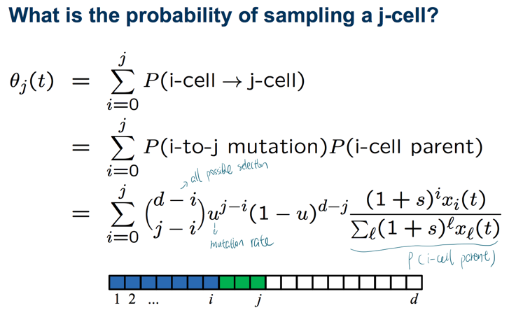

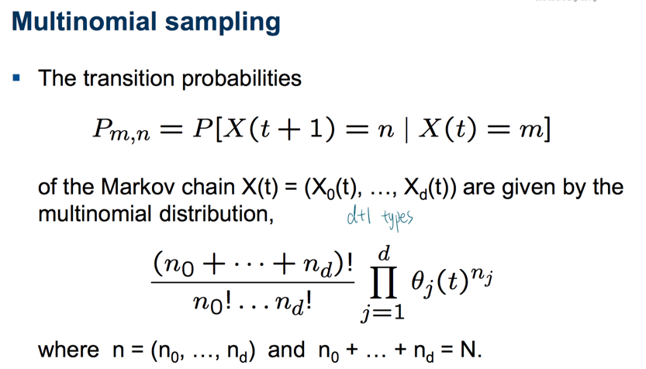

**Approximating the average waiting time**

Assumption: 1. each mutant wave has a Gaussian shape; 2. waves travel at constant

speed; 3. s << 1, so ${\left(1 + s\right)}^{j} ≈ 1 + sj$

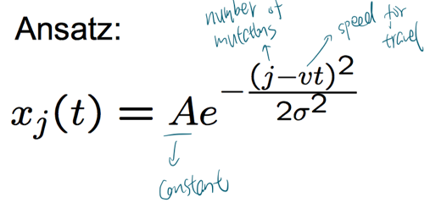

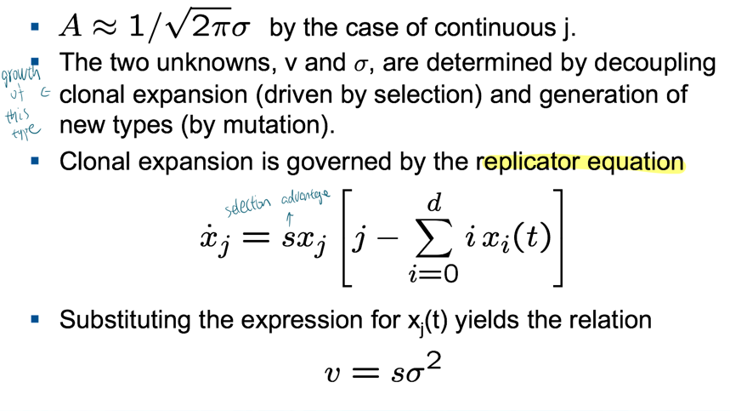

Consider an additional mutation when the number of current mutations is j

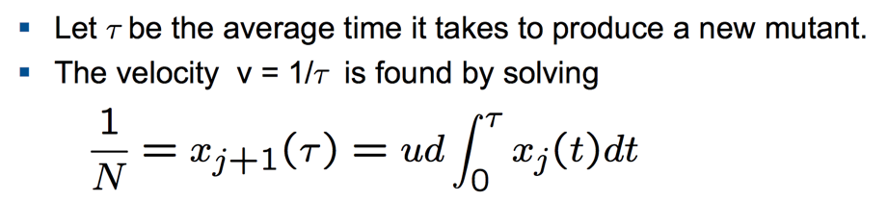

Based on the fact that initially ${ x}_{j}$ grows exponentially. And clonal expansion follows the replicator equation.

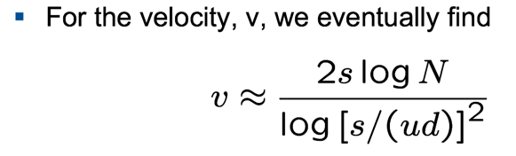??

This is (an approximation of) the speed of adaptation in an asexual population evolving according to the Wright-Fisher process.

The average time it takes until the first cell with k mutations appears is approximately

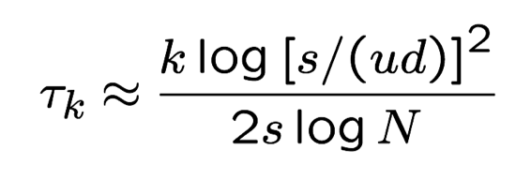=> **waiting time to cancer**

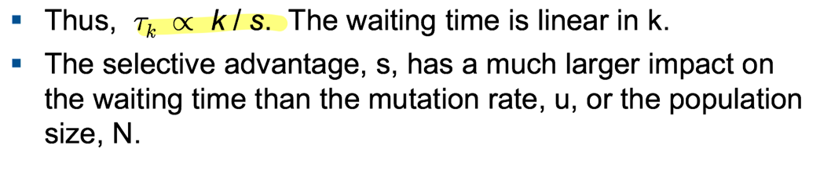

**Diffusion theory**

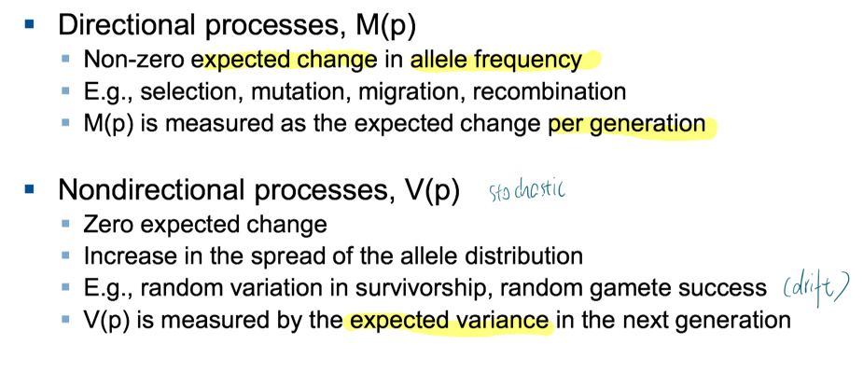

**For example in Moran process**

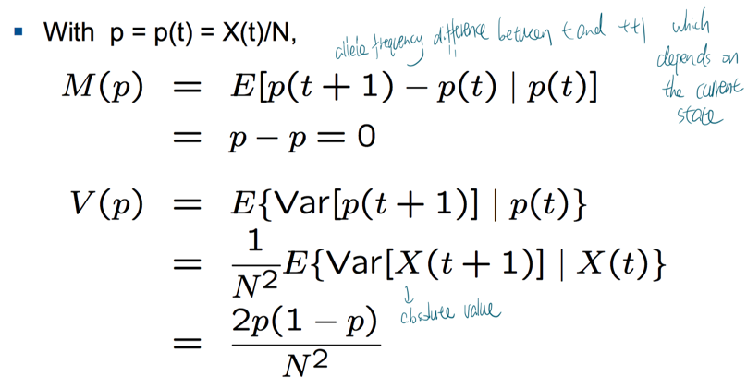

**Diffusion equation (Forward equation)**

Assume that

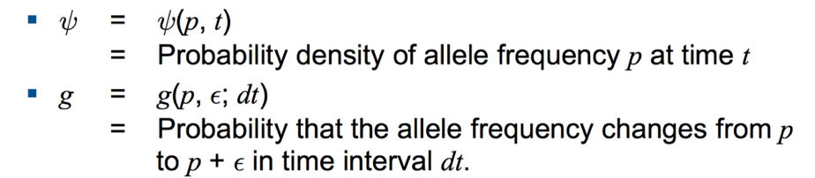

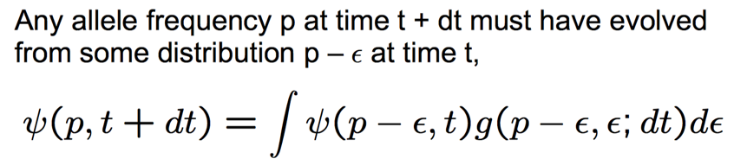

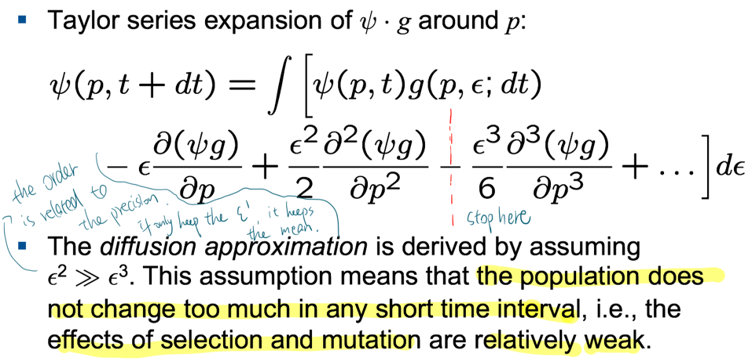

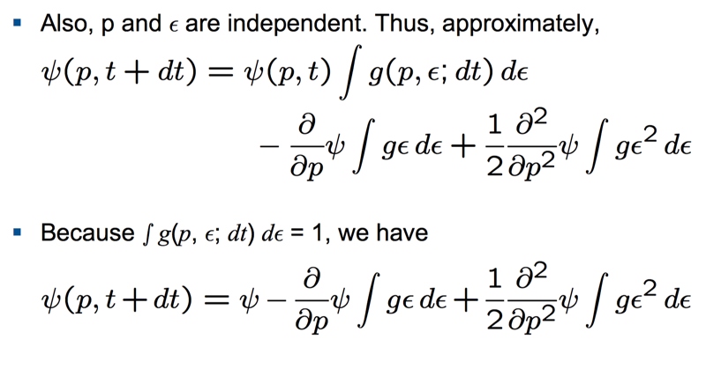

**The meaning of the integrals**

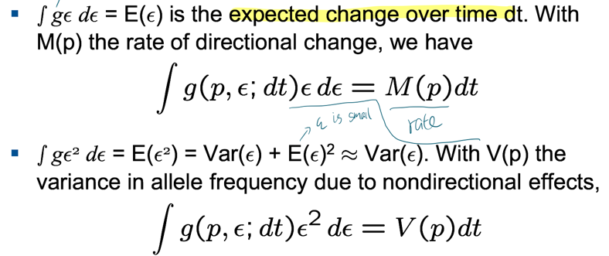

Therefore, the diffusion equation (Kolmogorov forward equation, Fokker-Planck equation) is

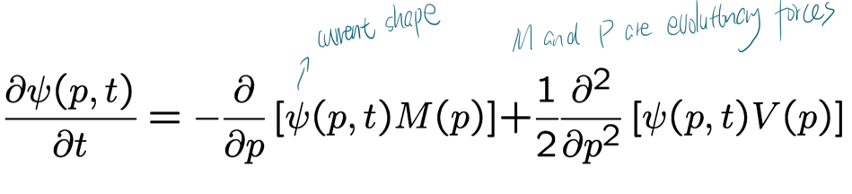

**Equilibrium**

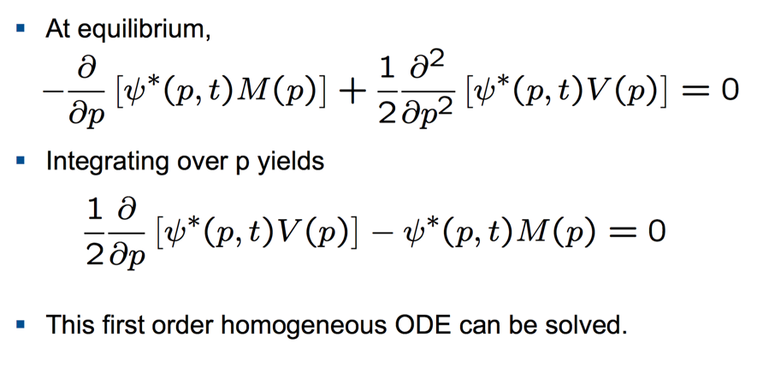

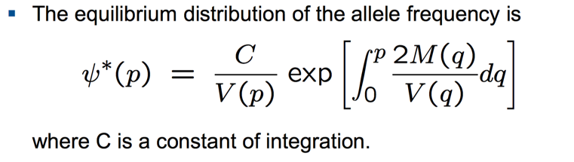5

**Computing M(p)**

**Selection**

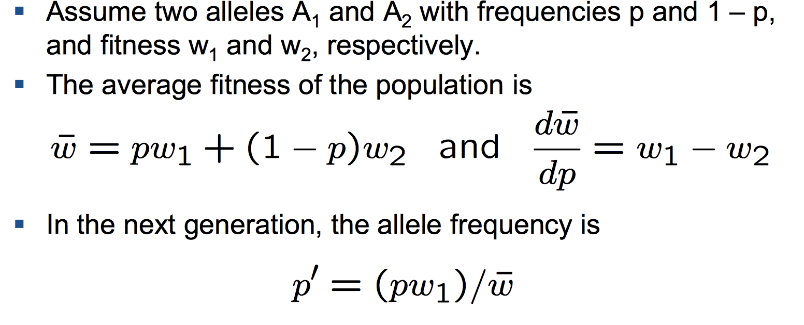

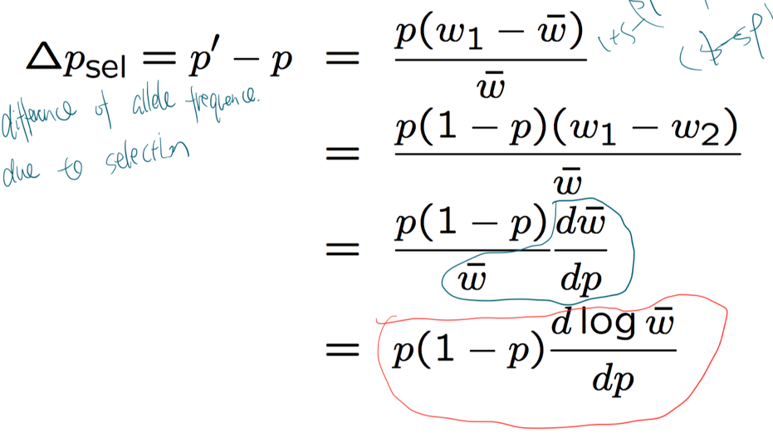

**Mutation**

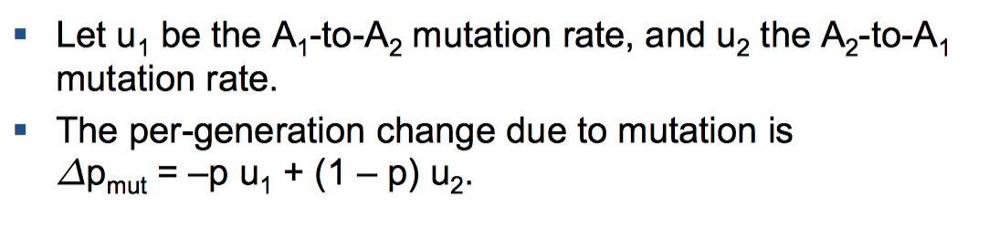

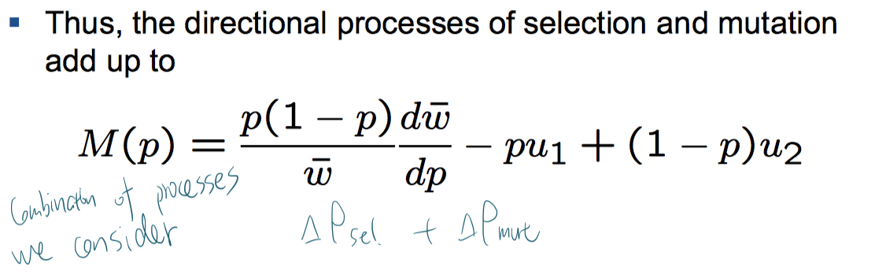

Computing V(p) (assume WF process)

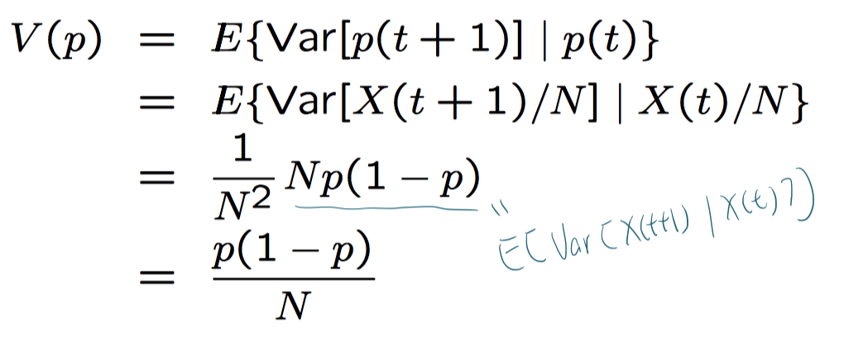

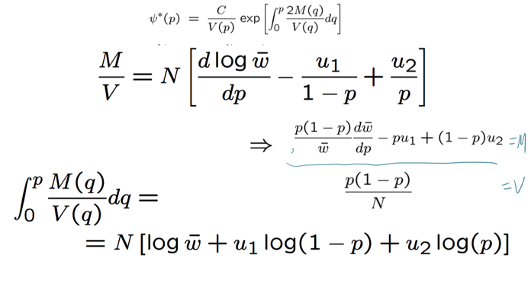

**Computing equilibrium**

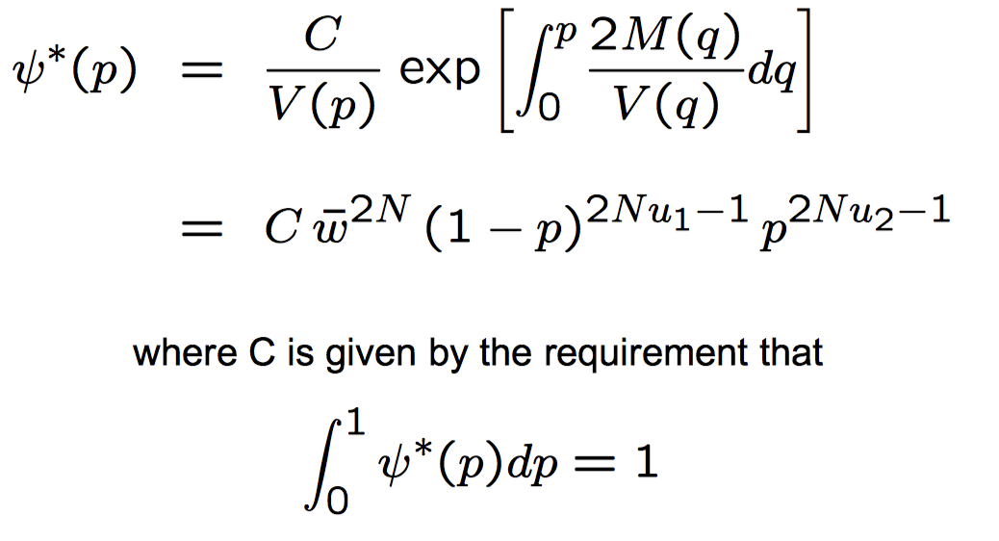

**For neutral variation**

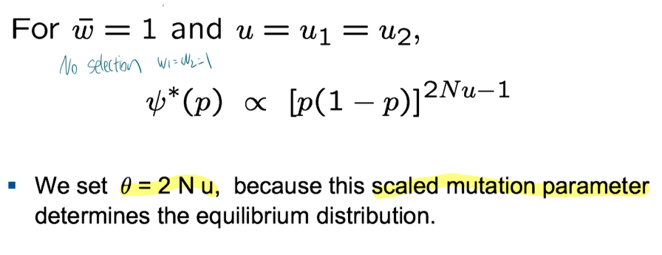

**For selection**

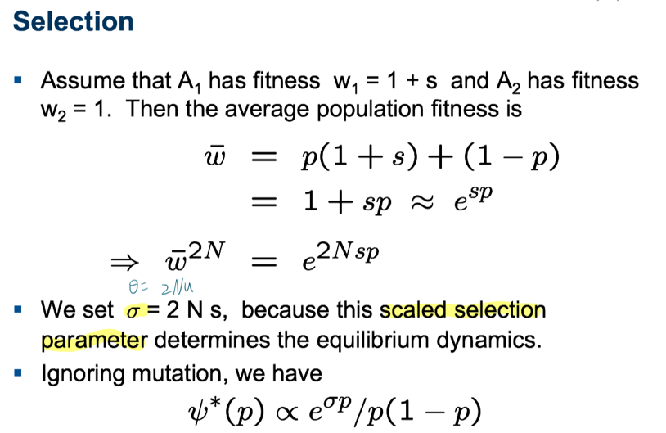

**Summary**

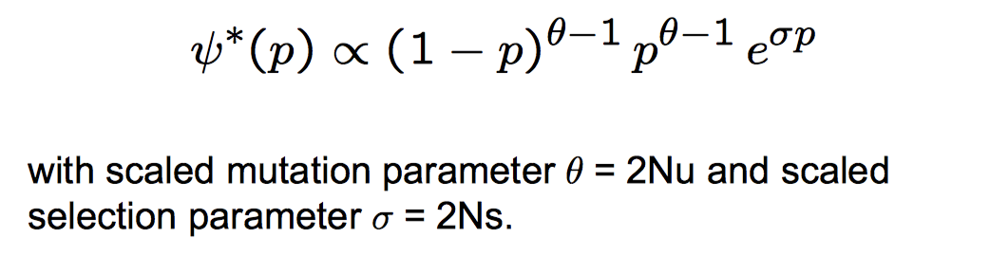

**Backward equation**

When the allele frequency is p0 at time t0

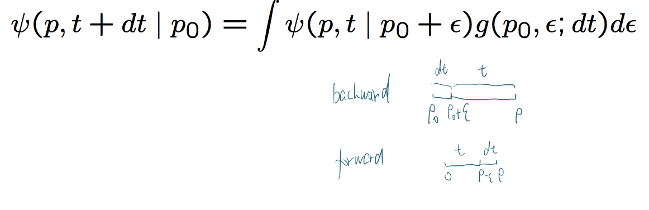

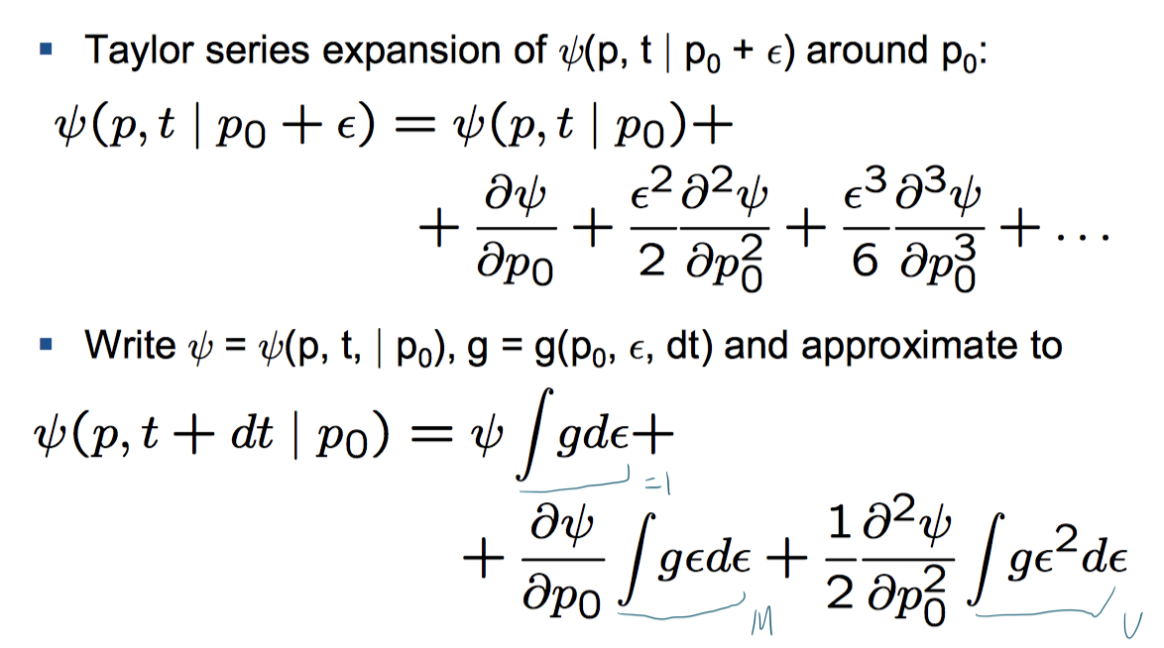

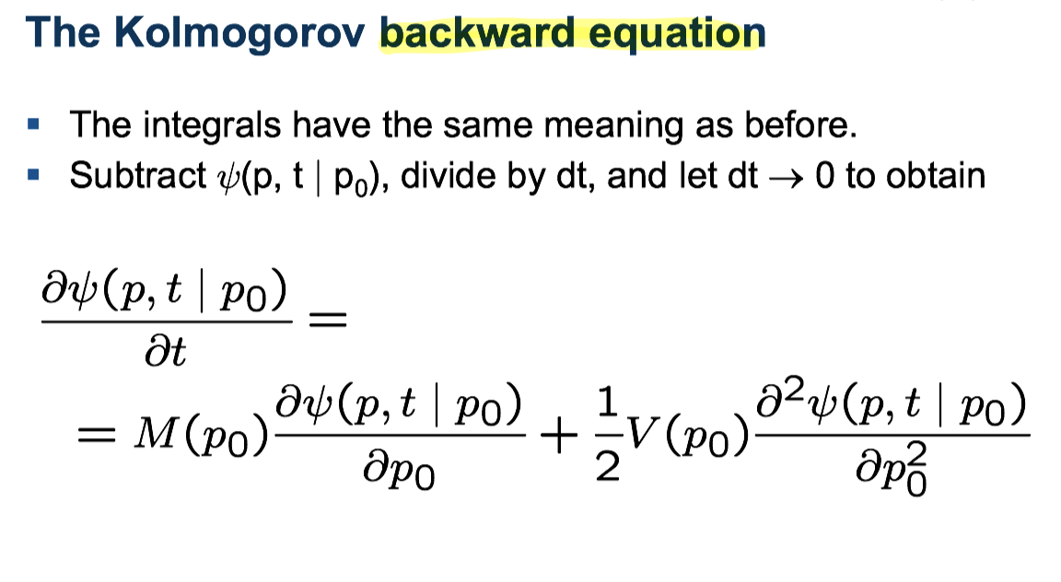

**Equilibrium**

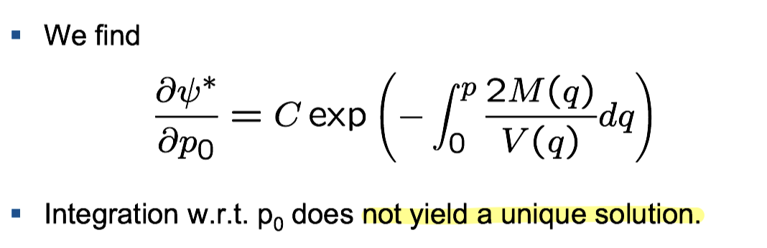

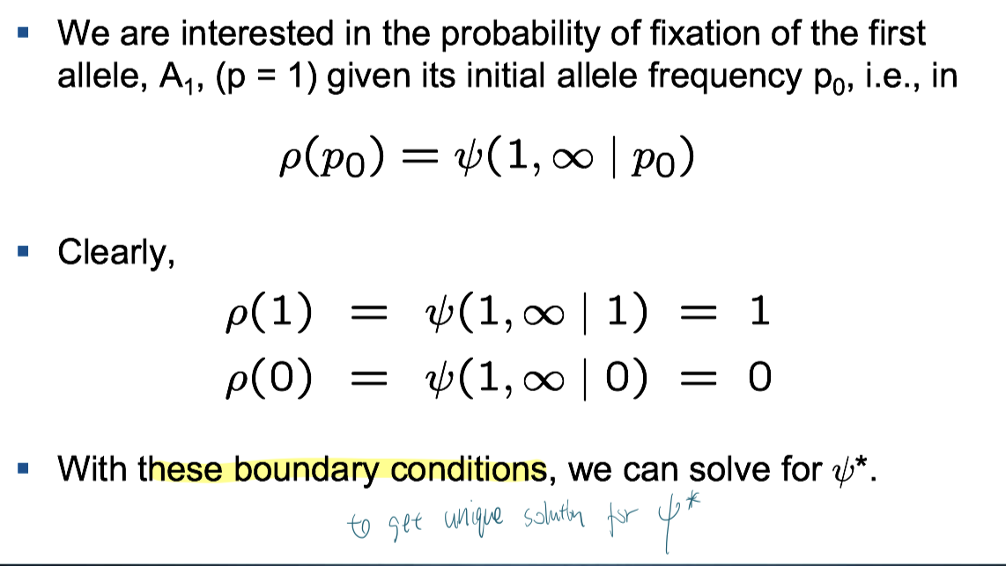

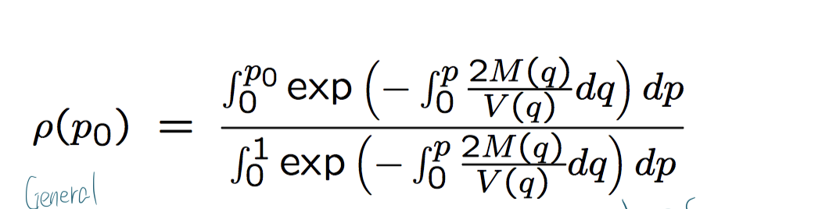

**Computing M(p) and V(p) (assume WF process)**

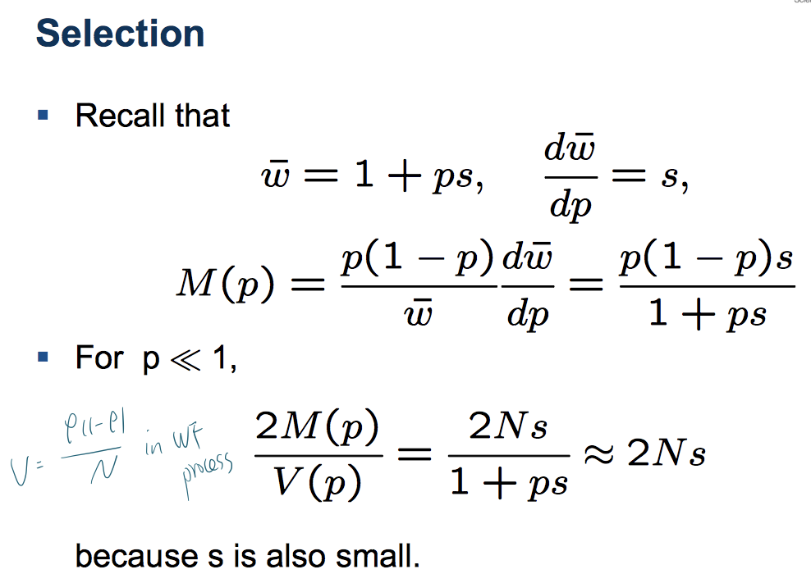

**Computing fixation probability**

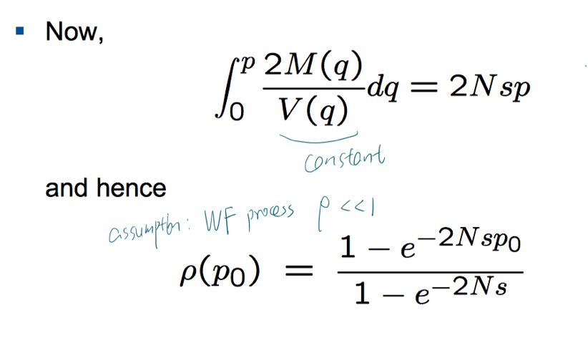

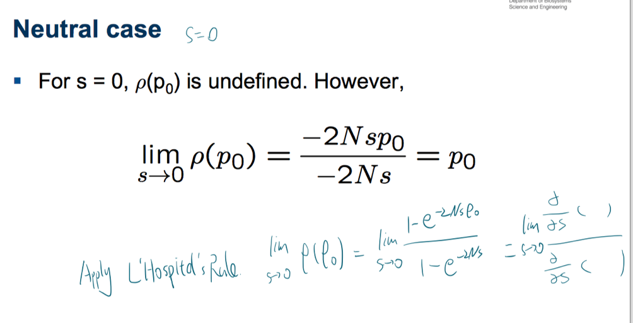

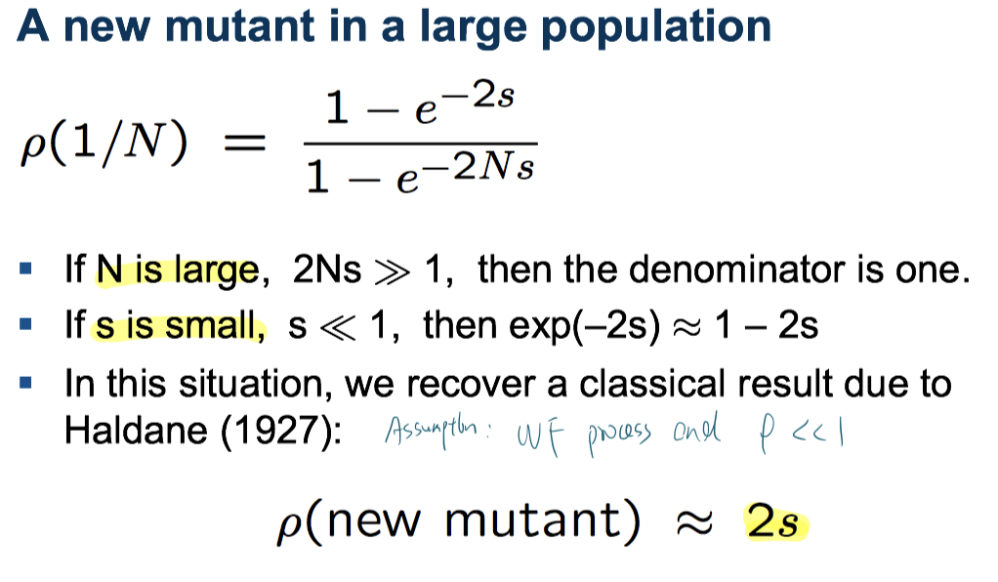

**Mean fixation time**

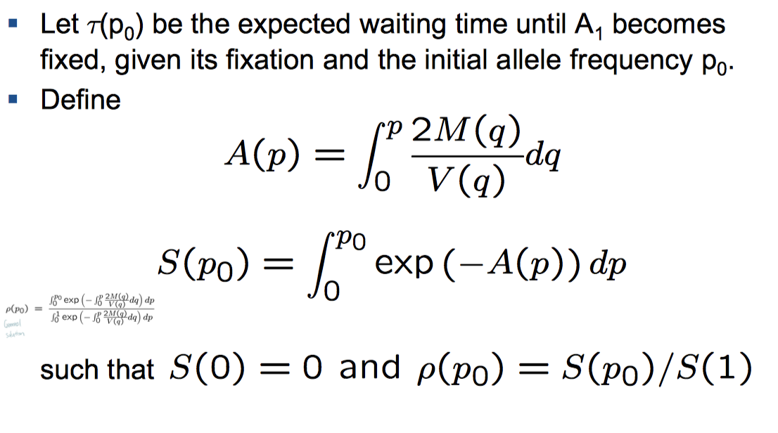

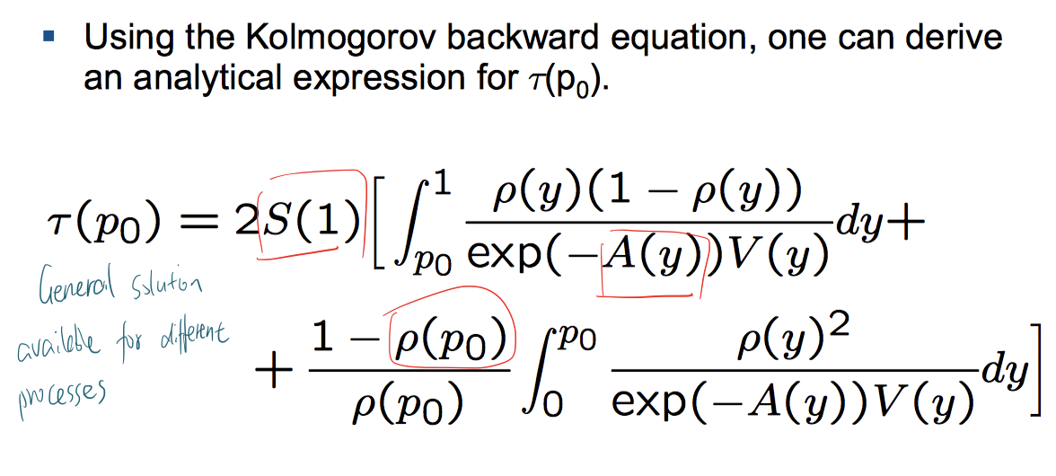 ??

For the neutral Wright-Fisher model

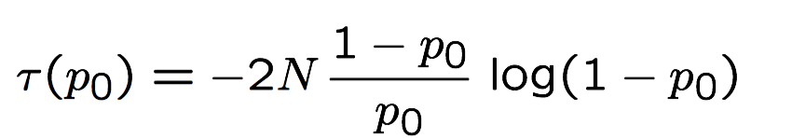



**Evolutionary game theory**

**Assume frequency-dependent selection**

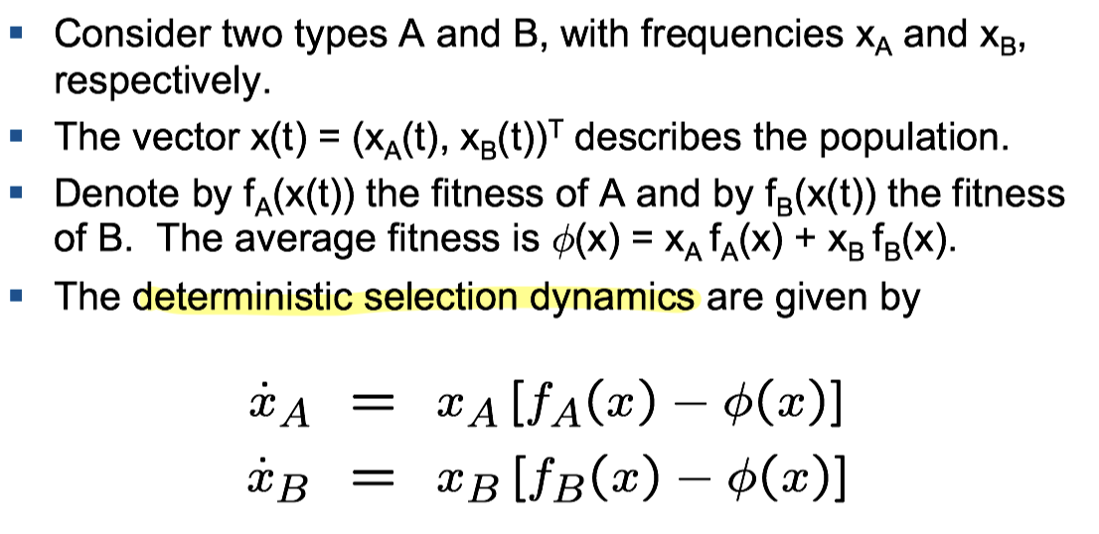

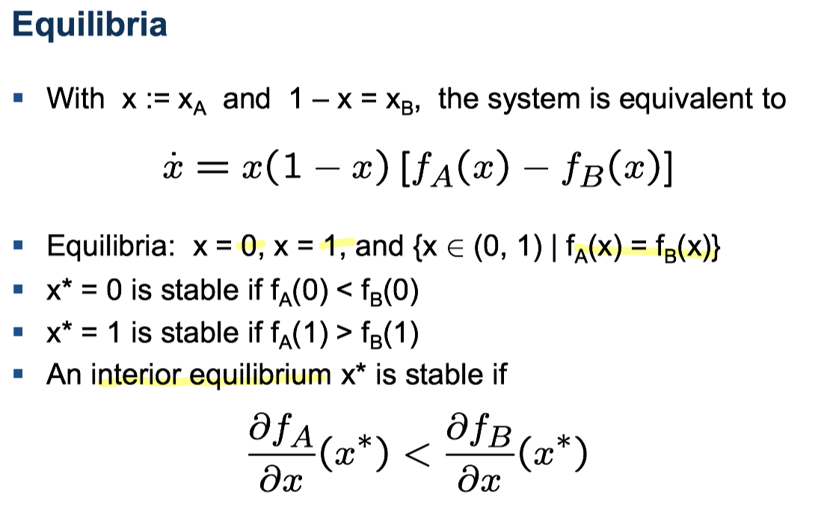

**Evolutionary games with two players**

**Payoff matrix**

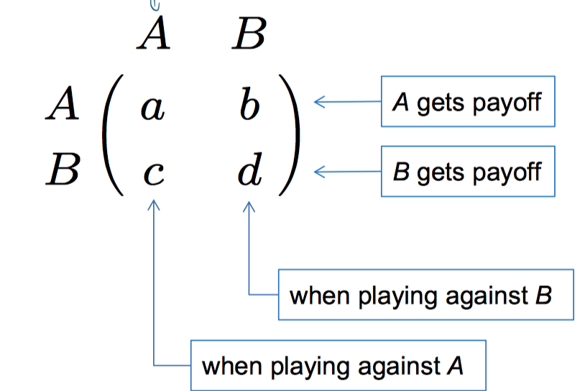

**Fitness** = expected payoff

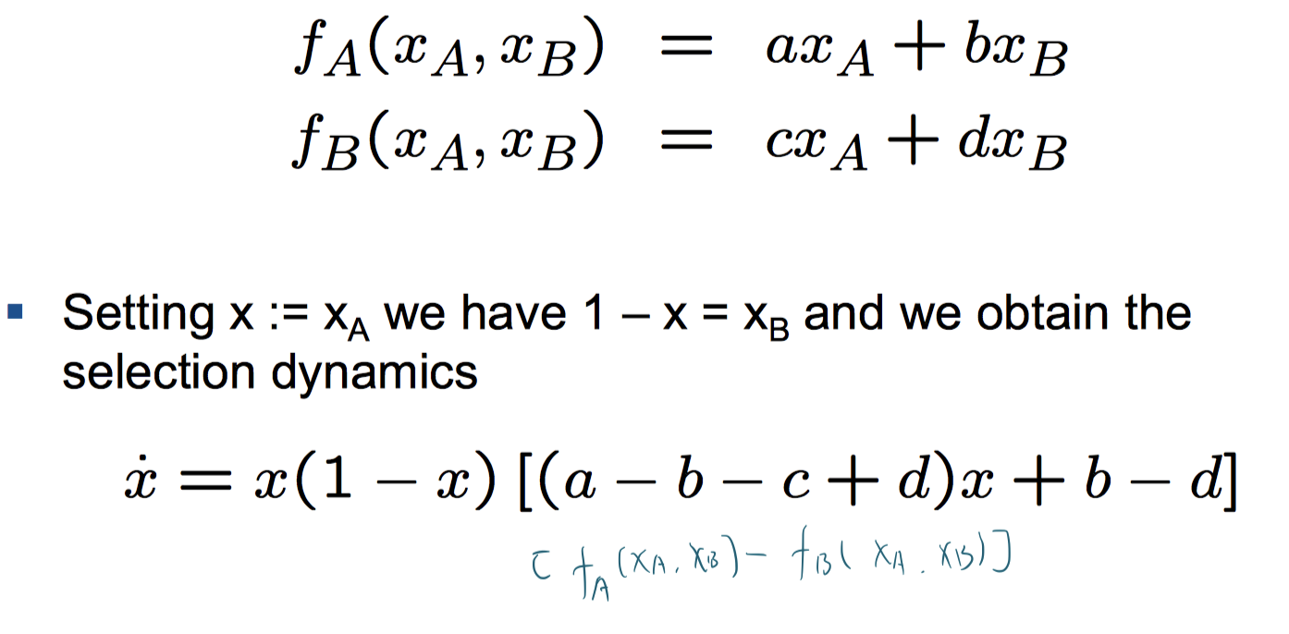

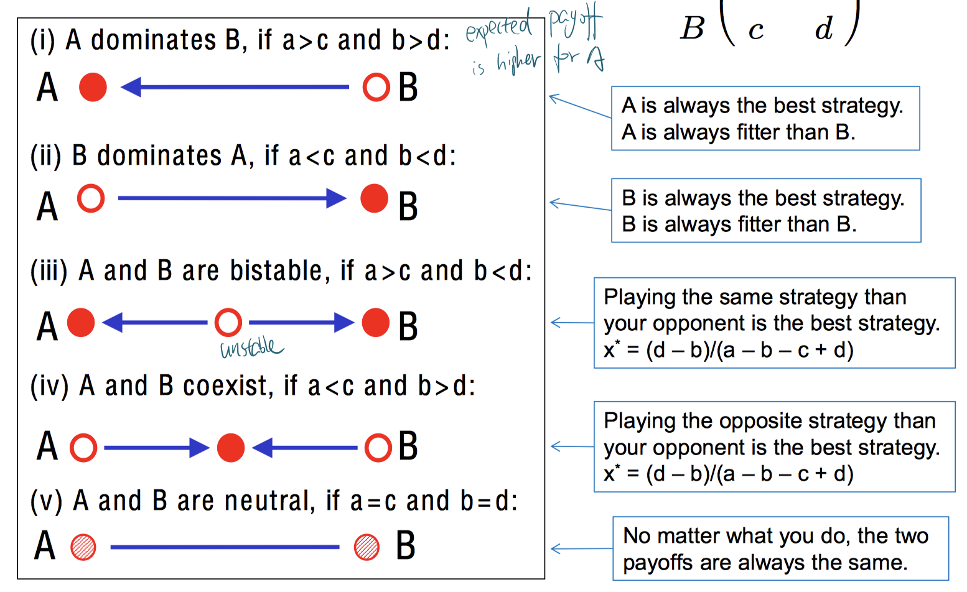

**Nash equilibrium**

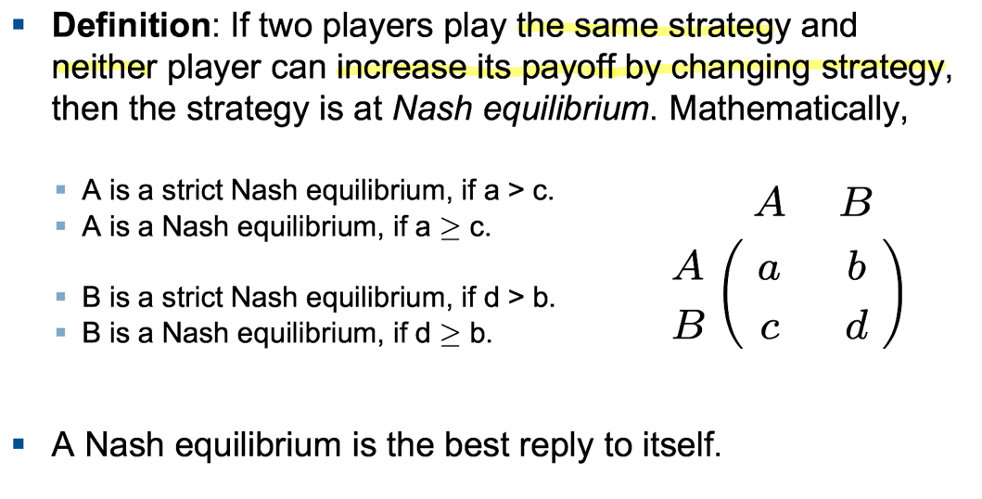

**Evolutionary stable strategy (ESS)**

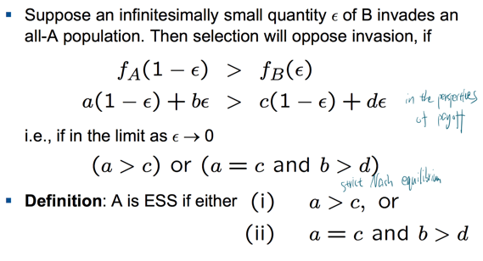

($x^{*}=1 is stable equilibrium$)

**More than two strategies**

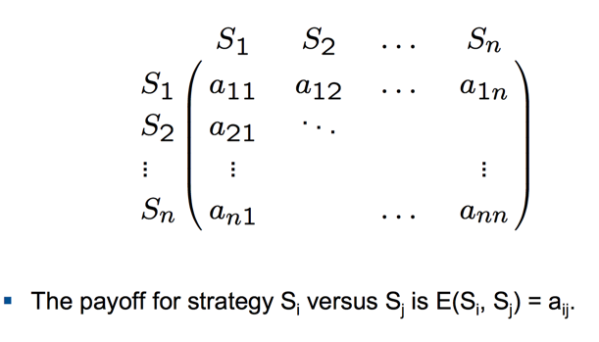

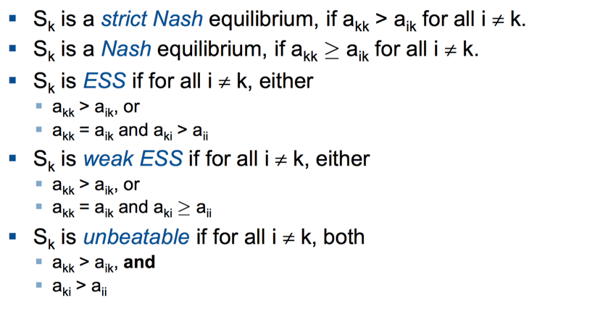

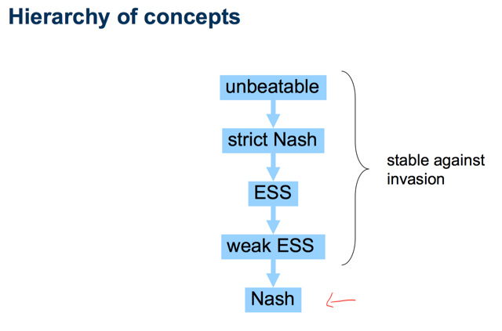

**Fitness among n players**

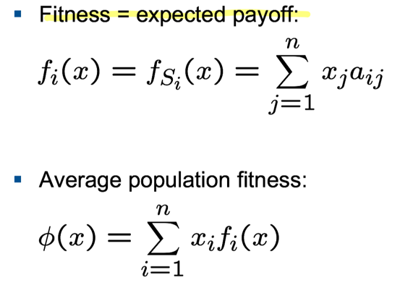

**The replicator equation**

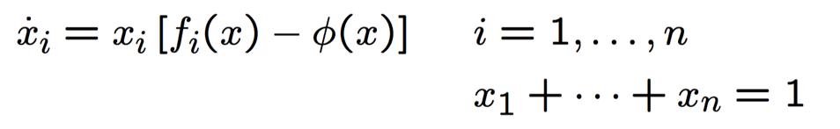

Rock-paper-scissors (RPC)

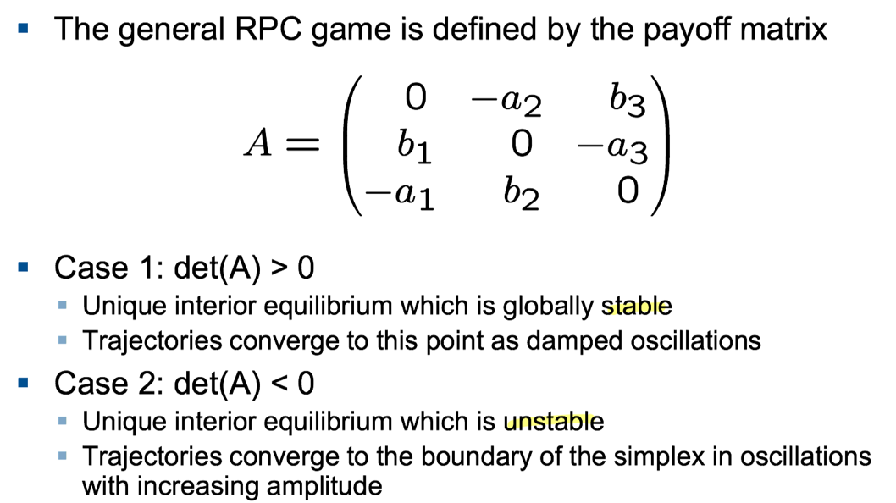

**Hawks and doves**

from the perspective of individual selection (rather than group selection).

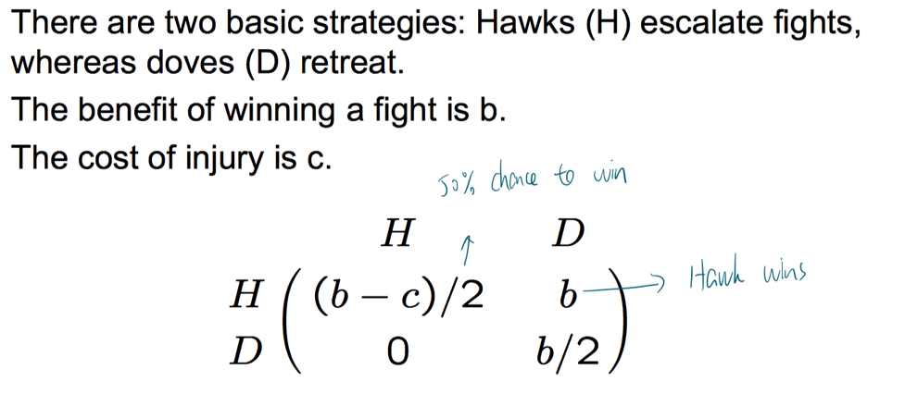

Often, the cost of injury will be larger than the benefit of escalation (b < c). If b < c, then neither strategy is a Nash equilibrium. Hawks and doves can coexist. The equilibrium hawk

frequency is $x_{H}^{*}=\frac{b}{c}$

**Mixed strategies**

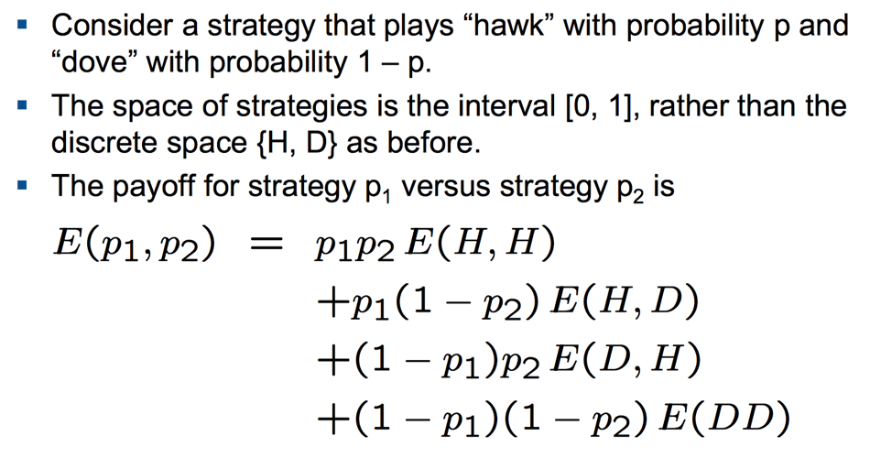

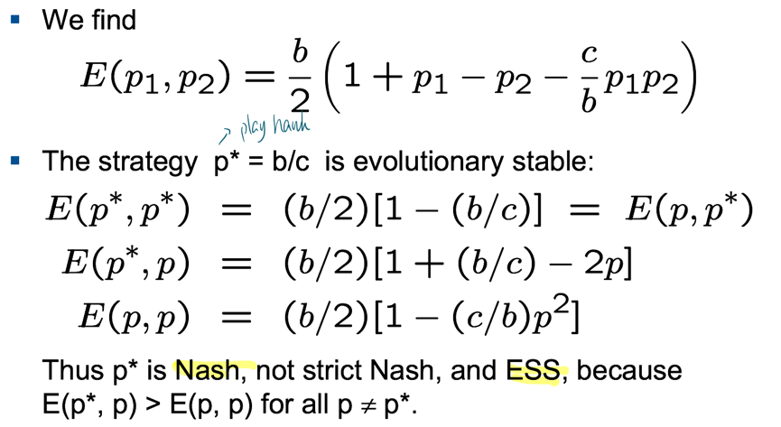

**Cooperation and defection**

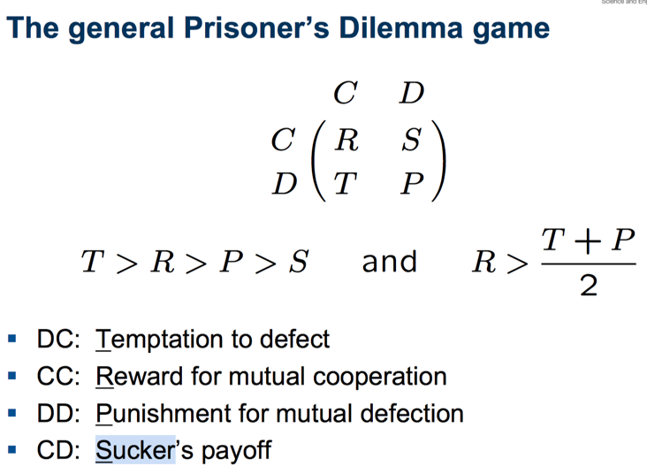

1. **Direct reciprocity**

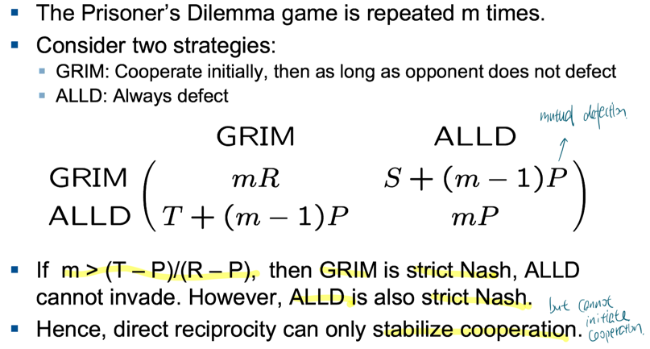

1. **Defecting in the last round (know the number of rounds)**

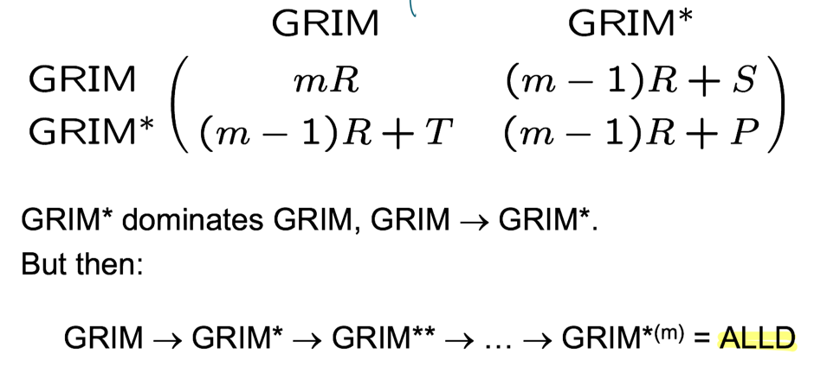

1. **Variable number of rounds** (Defecting in the last round is no longer possible)

Suppose that after each round there is a probability w that another round will be played.

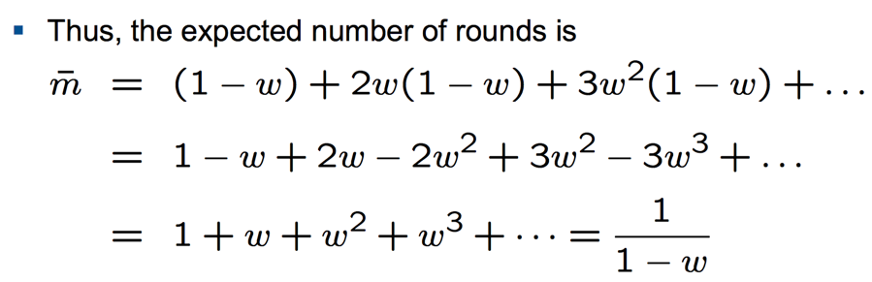

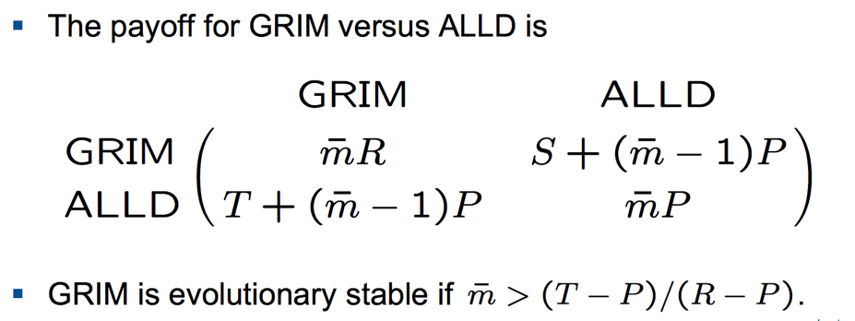

1. **Tit-for-tat**: start with cooperation, then do whatever your opponent has done in the previous round, i.e., answer C for C and D for D.

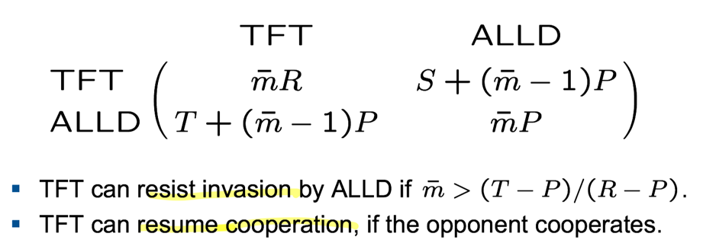

In the long run, the payoff is as low as choosing randomly between C and D because TFT is susceptible to noise. $E\left(TFT, TFT\right)=\frac{T+R+P+S}{4}< R$

1. **Reactive strategies**

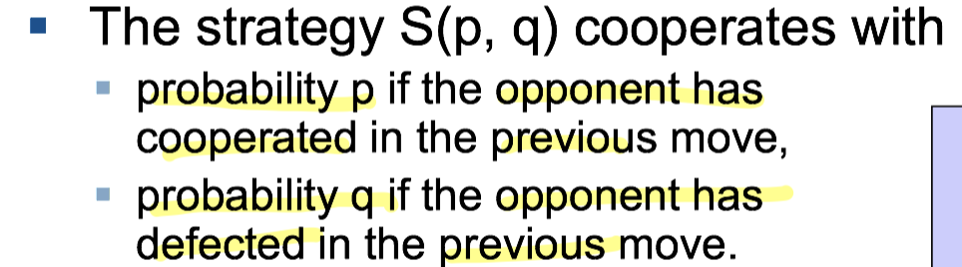

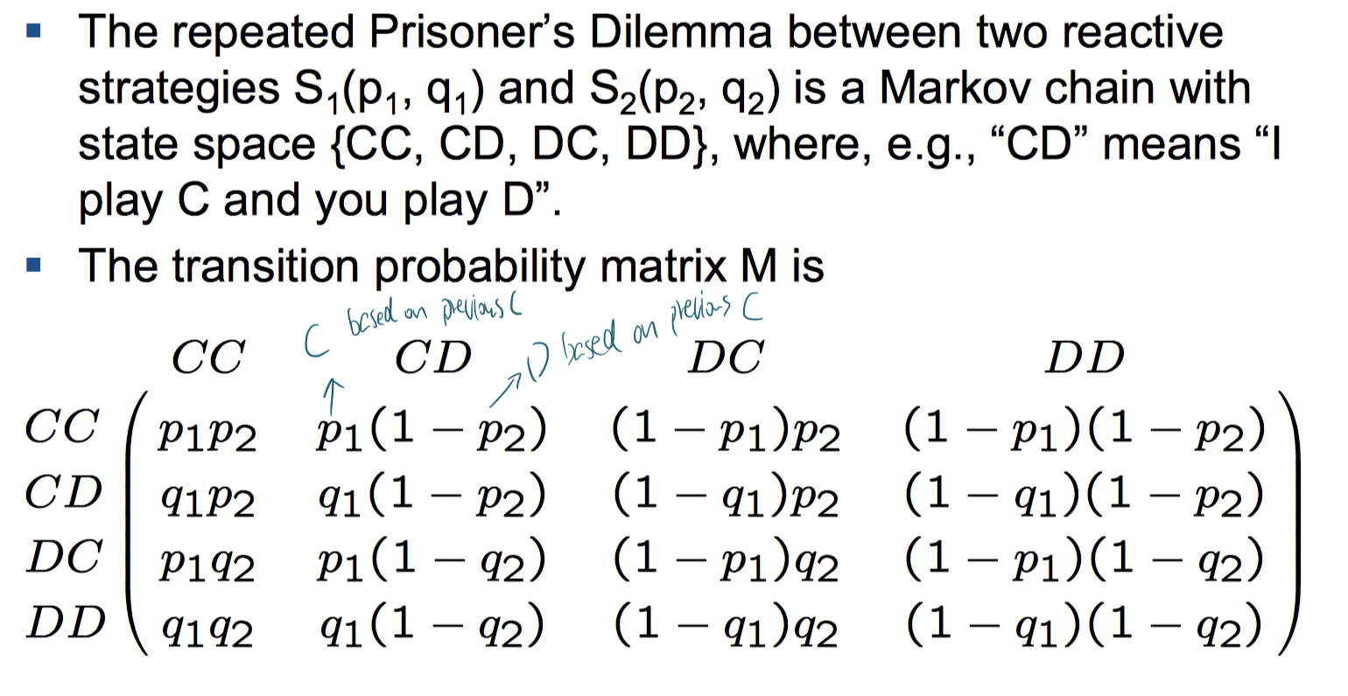

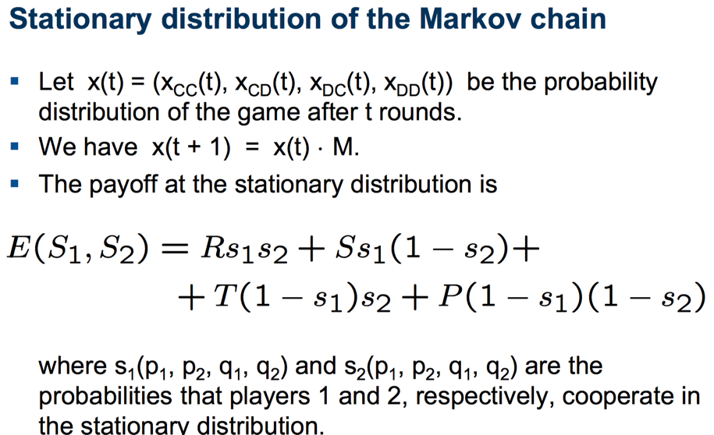 ??

1. **Generous Tit-for-tat (GTFT**) i.e.GTFT = S(1, 1/3)

E(GTFT, GTFT) is close to R, because GTFT can correct mistakes

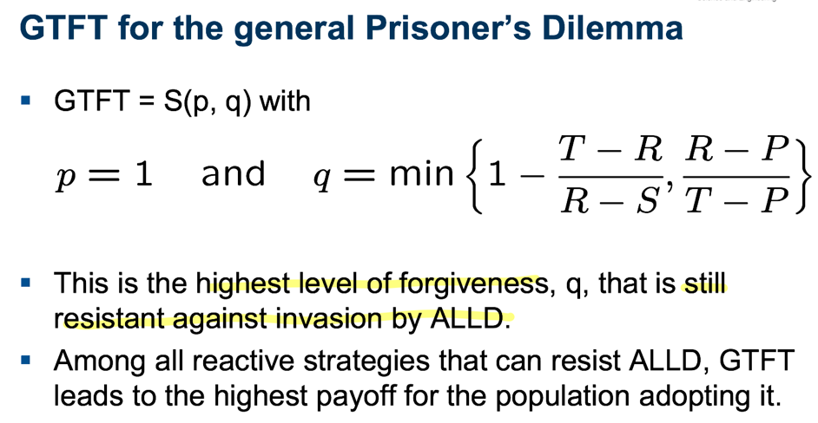

??

1. **Memory-one strategies**

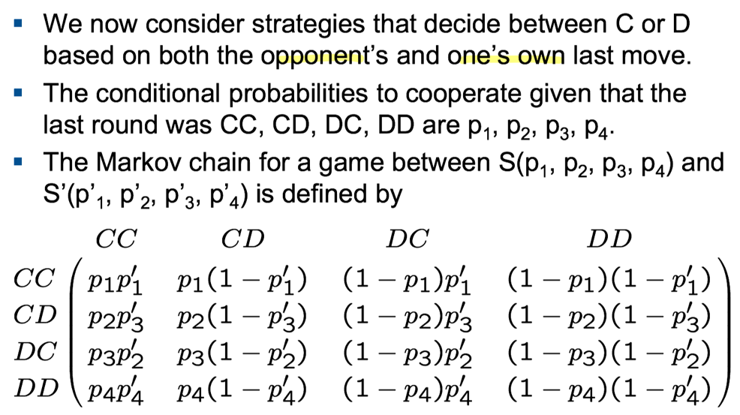

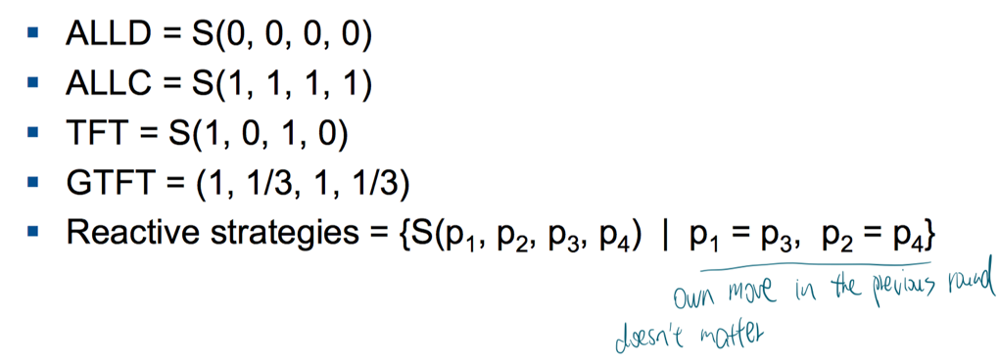

1. **Win-stay, lose-shift** (WSLS)

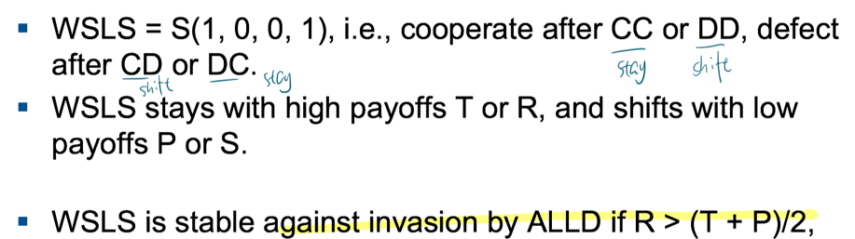

WSLS is a deterministic corrector, whereas GTFT is a stochastic corrector. WSLS dominates ALLC. GTFT does not dominate ALLC.

**Evolutionary games in finite populations**

Expected payoff

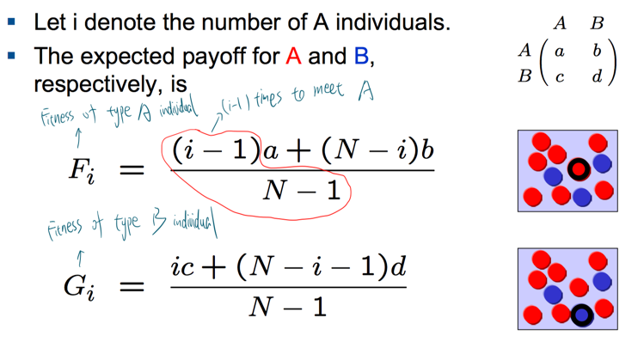

Selection opposing invasion

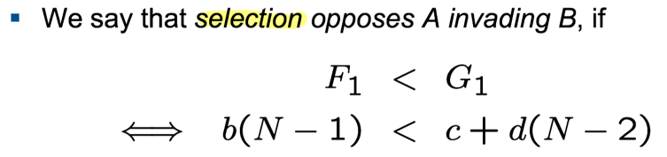

The condition is independent of a. For N = 2, we have b < c

Intensity of selection

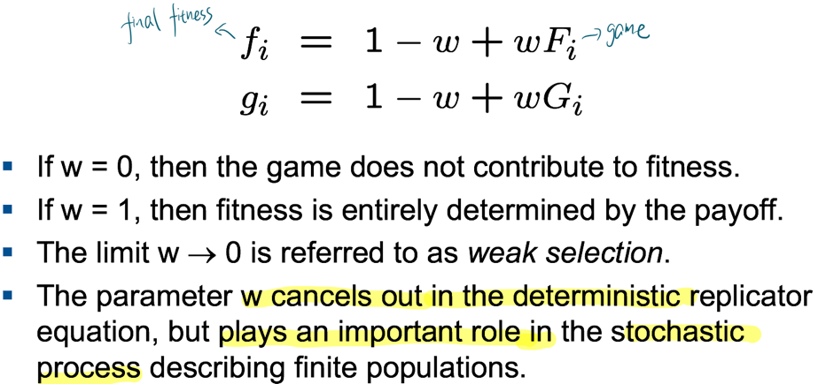

Fixation probability in Moran process

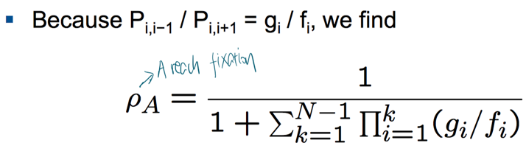

When applying weak selection limit

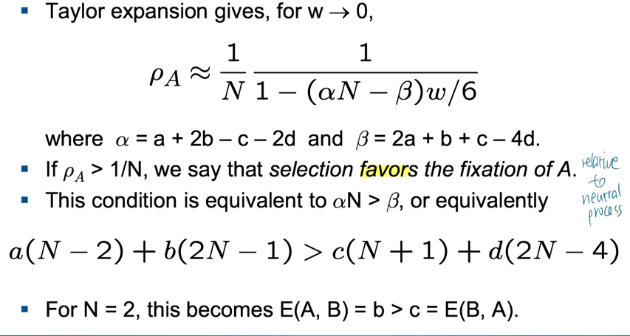

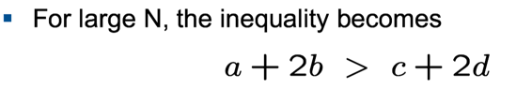

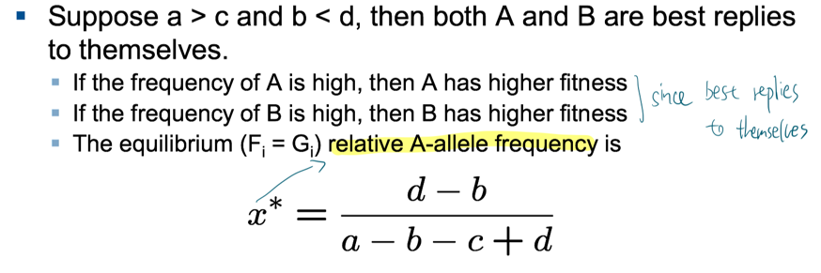

The 1/3 law (weak selection, large population)

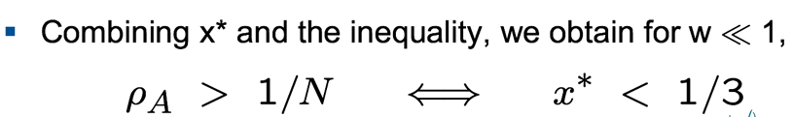

If the unstable equilibrium occurs at a frequency smaller than 1/3, then in a large finite population, in the limit of weak selection, selection favors the fixation of A in B

Comparison with infinite population

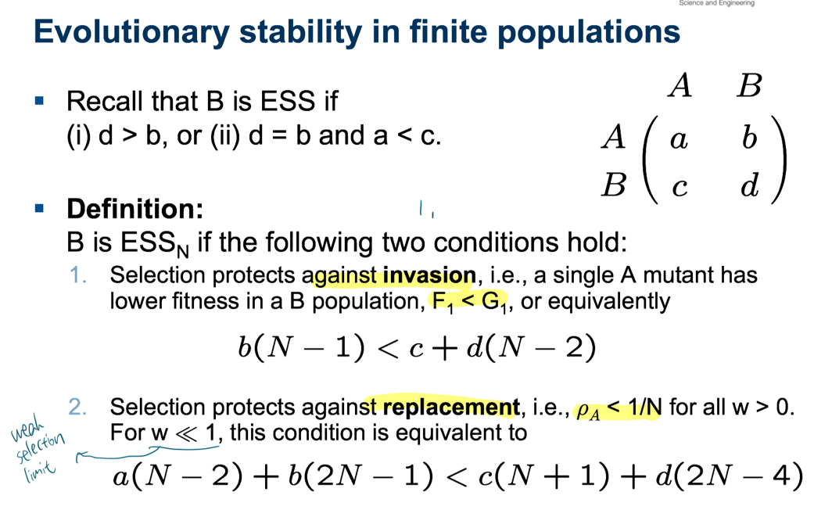

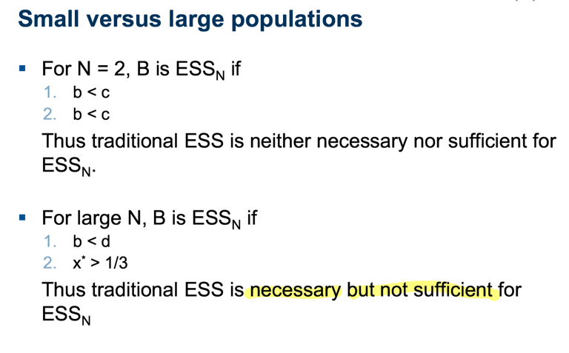

Risk dominance

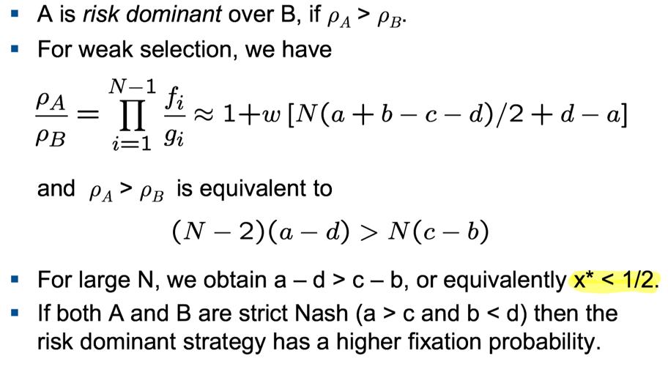??

When A = TFT B = ALLD

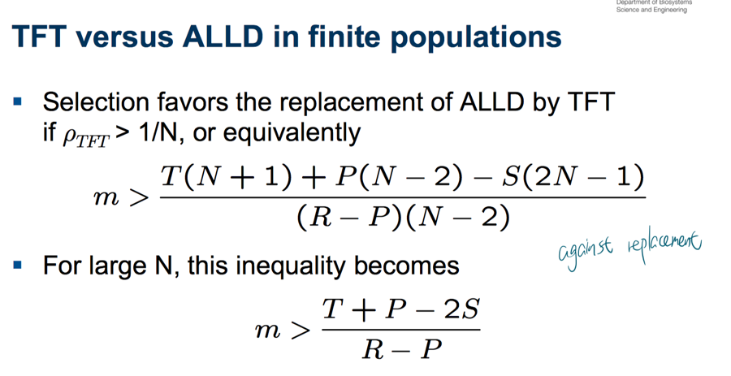

**Evolutionary graph theory**

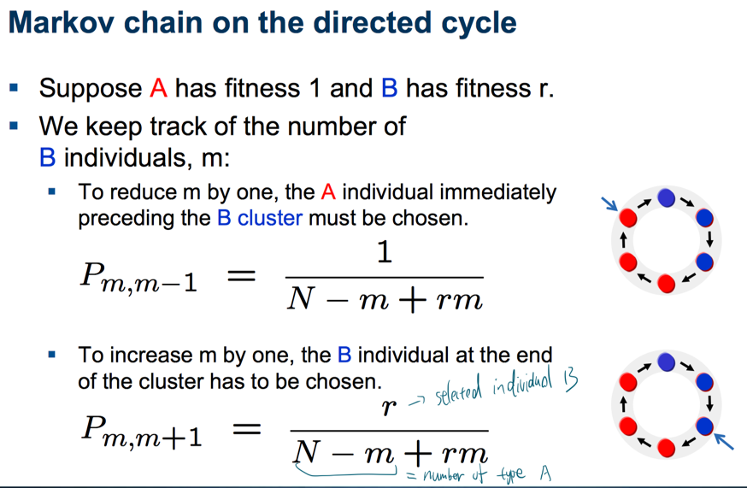

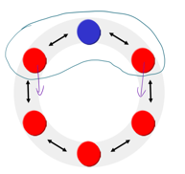

Fixation probability on the directed and bidirected cycle is same as Moran process since $γ_{m}=\frac{P_{m,m-1}}{P_{m, m+1}}=\frac{1}{r}$

Amplifiers and suppressors

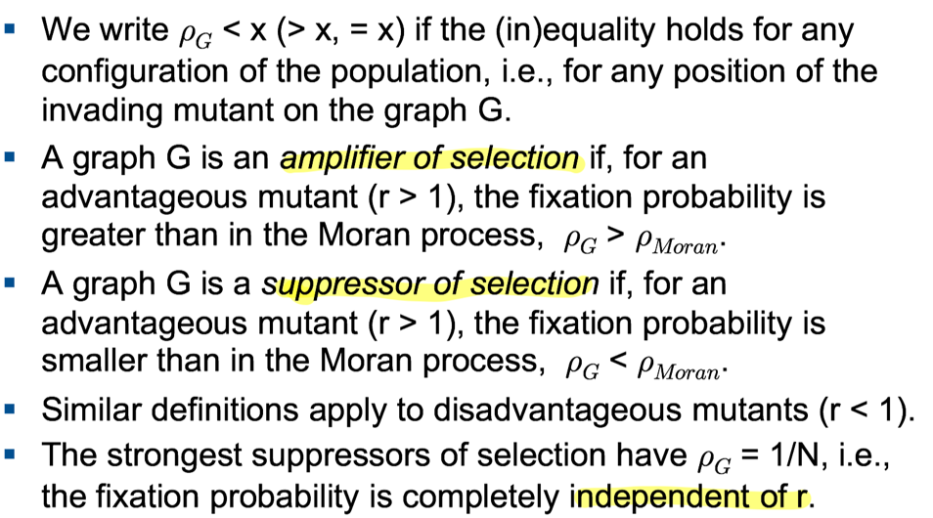

The line and The burst

The isothermal theorem

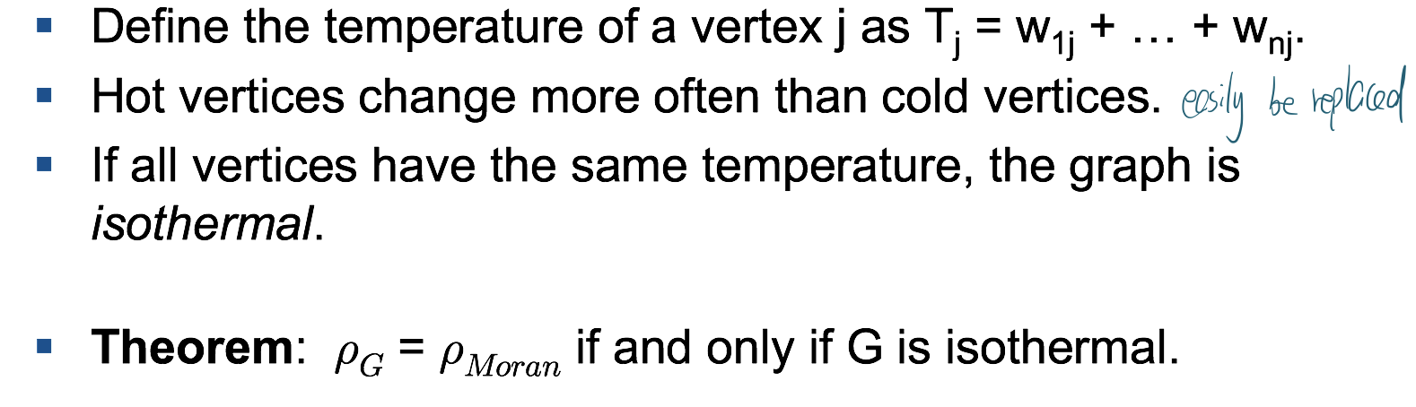

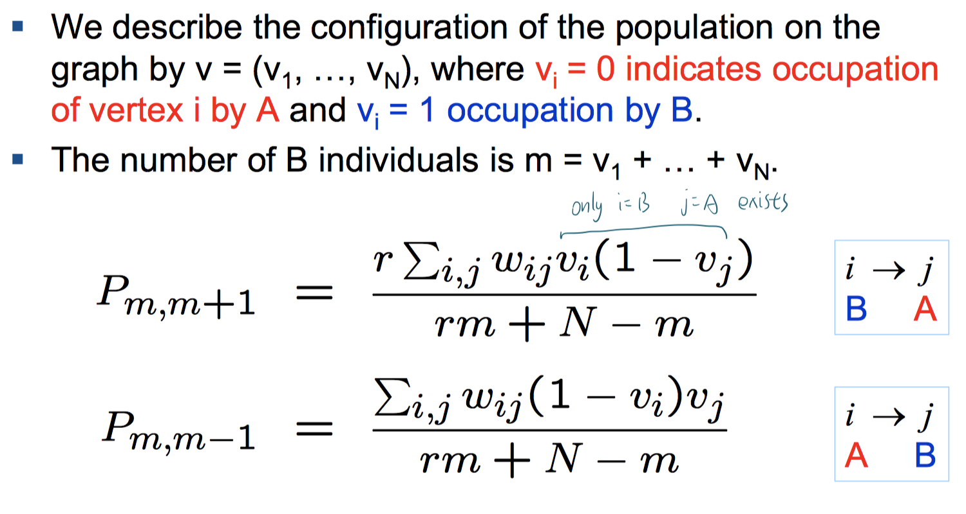

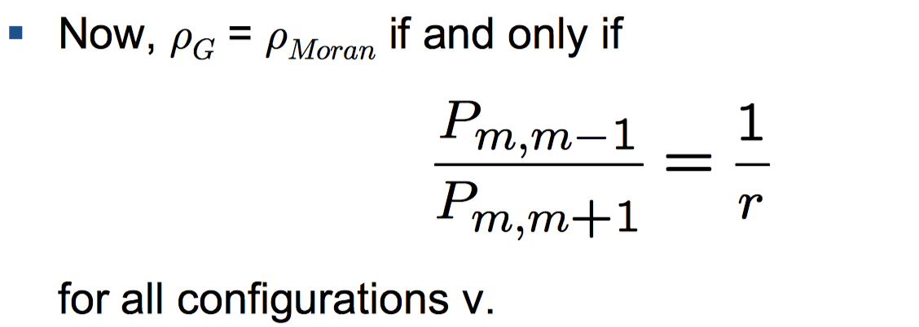

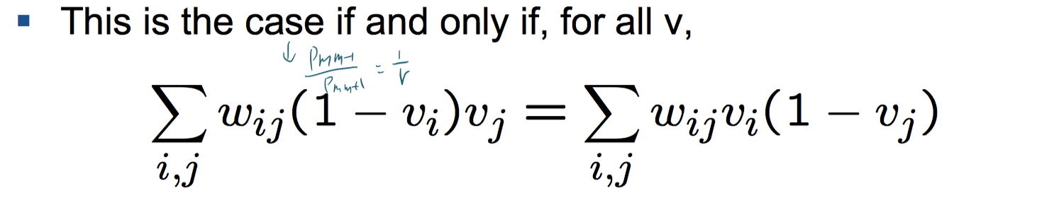

Condition for isothermal graphs

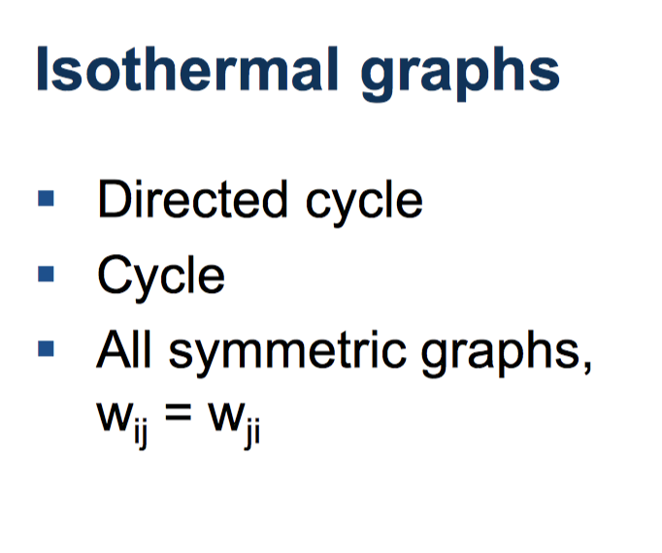

Payoff on graph

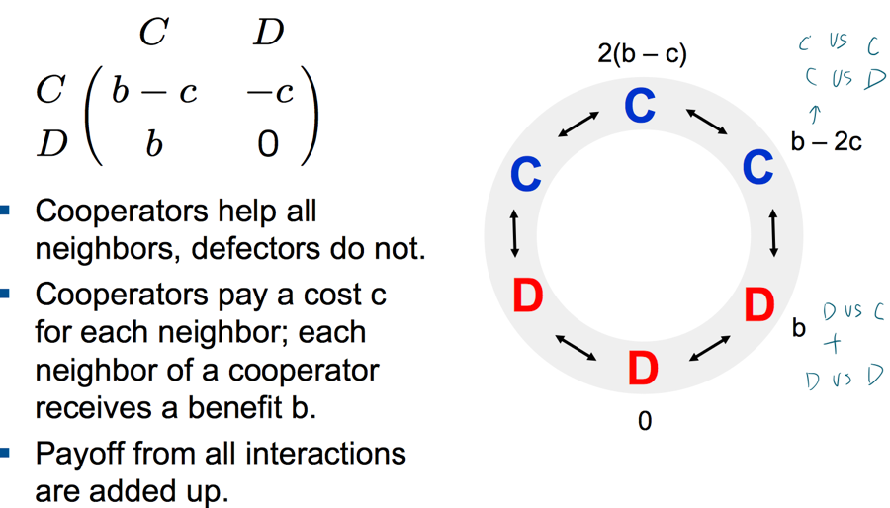

**Spatial models of the evolution of solid tumors**

Cellular automata

Eden growth model

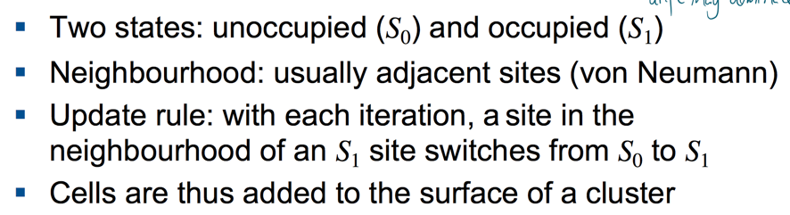

Eden growth model variants (different way to choose sites to be updated)

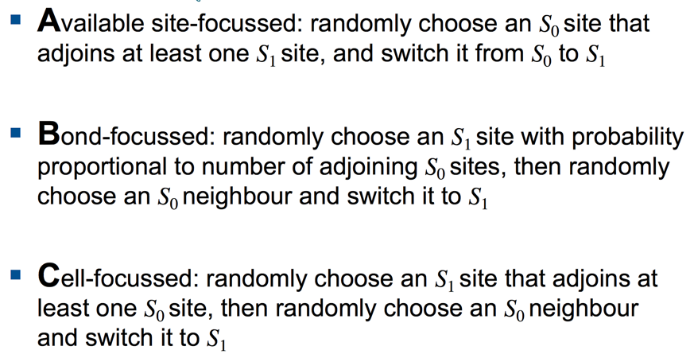

With mutation

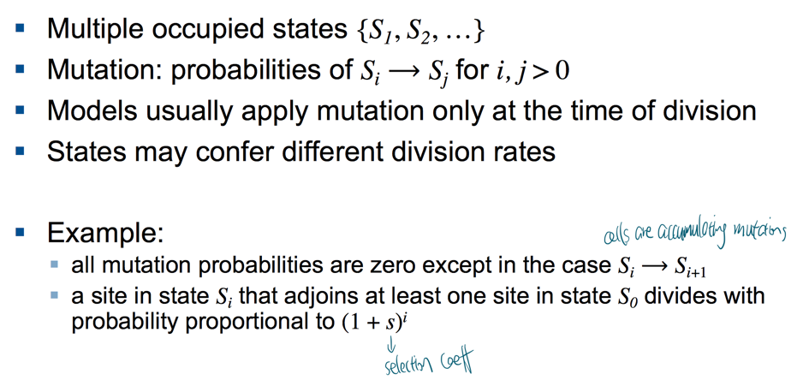

Deme-based models

Each site (deme) contains multiple cells (e.g. demes correspond to glands or microenvironmental niches). Assume cells within demes are well-mixed and obey a local

subpopulation model such as the Moran process or Wright-Fisher process. Cells can migrate between demes.

Assume replacement probability is weighted by cell fitness ($\frac{\left(1+s\right)n_{i}}{N}$) The replacement has a local parent with probability (1 − m) or a parent from a neighboring deme with probability m

The aim of the present article is to study the dynamics of the into c

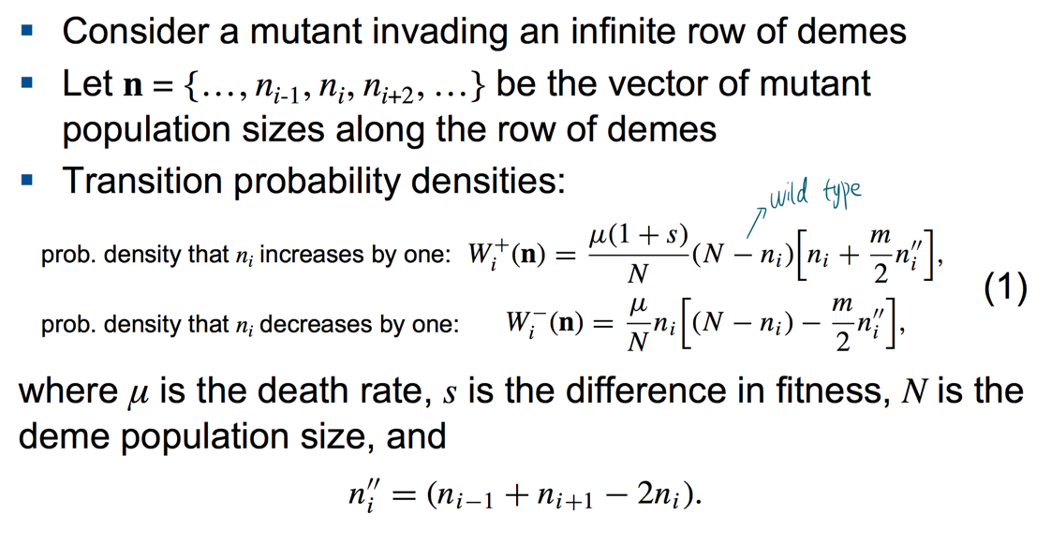

A variant of Fisher equation

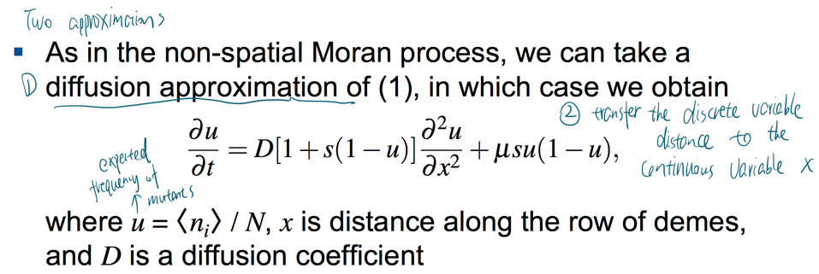

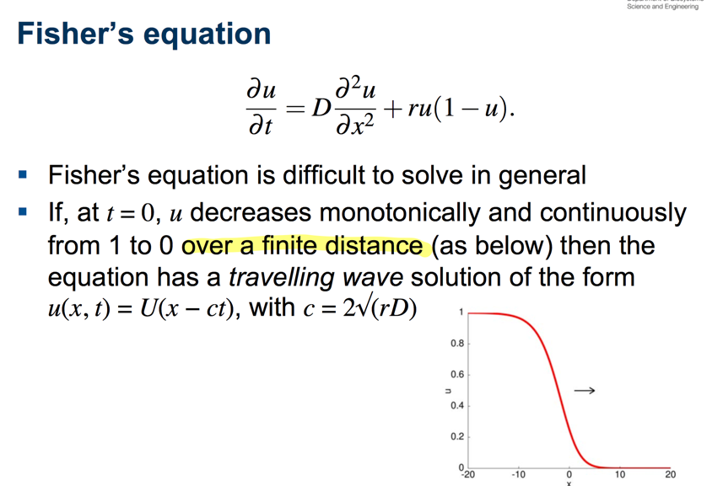

Gillespie stochastic simulation algorithm

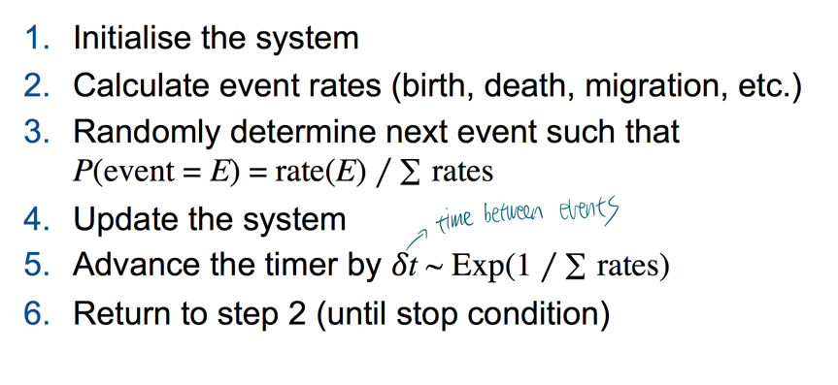

**Branching processes in biology**

(finite population but size may not constant)

**Galton-Watson process**

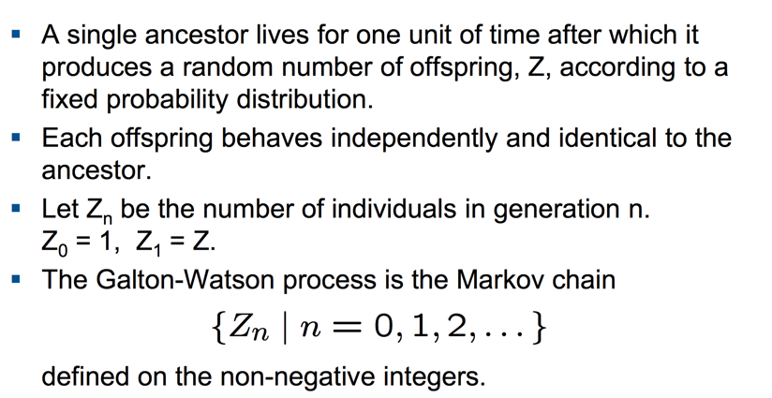

Transition probability

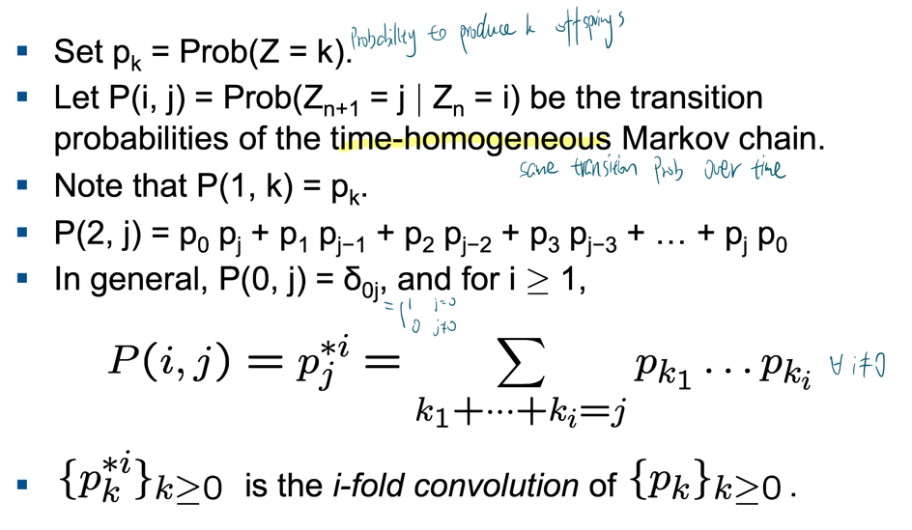

**Probability generating function (pgf)**

the main mathematical tool to study branching processes

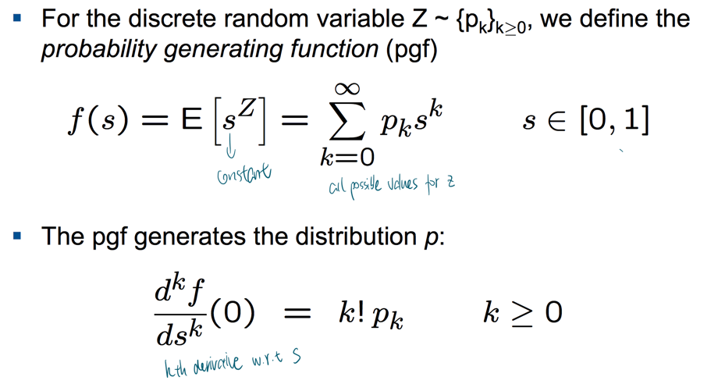

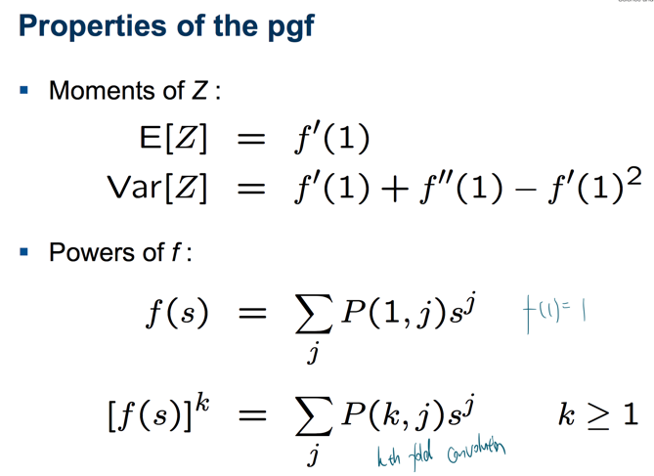

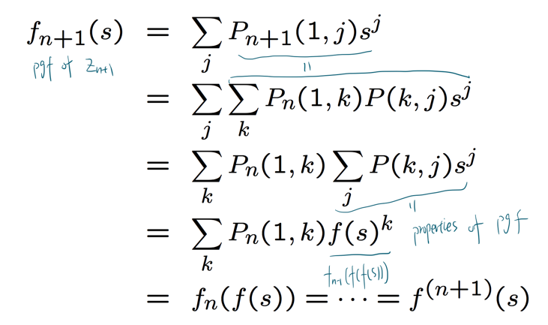

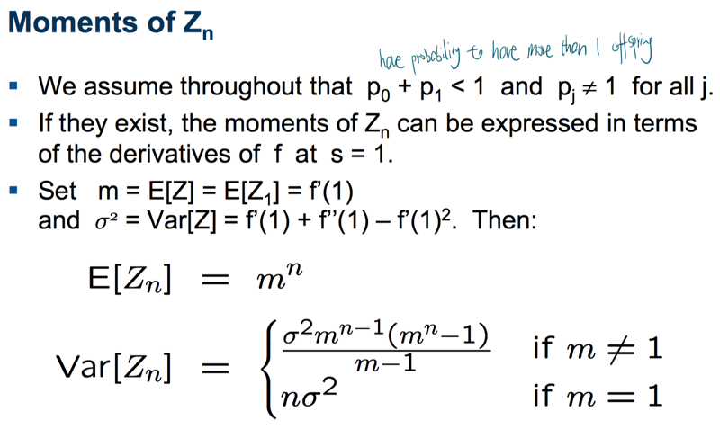

Extinction

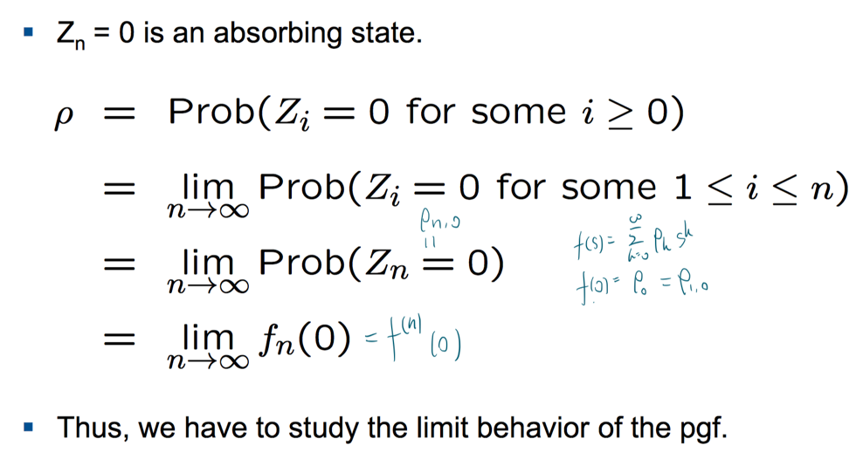

Extinction probability

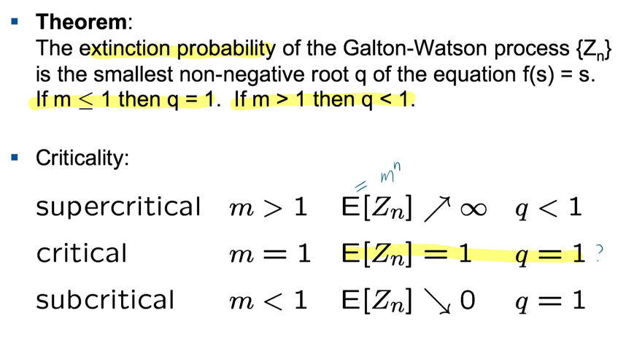

Instability

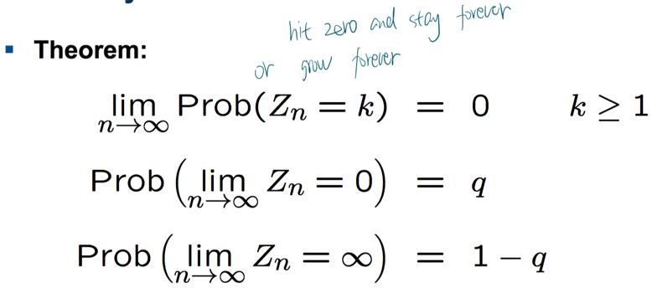

**The multi-type Galton Watson process**

1. Assume two types: type 0 (wild type) and type 1 (mutant) with counts $Z_{0}(t)$ and $Z_{1}(t)$, respectively, in generation $t∈ \{0, 1, 2, …\}.$
2. Each cell at the moment of division gives birth to two daughter cells, it meas the size of population is deterministic. A type 0 cell has type 1 offspring with probability $α$, the mutation rate. The mutation is irreversible: type 1 cells can not produce type 0 offspring

Probability generating function

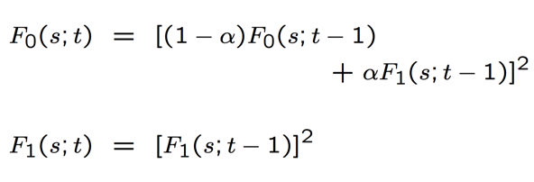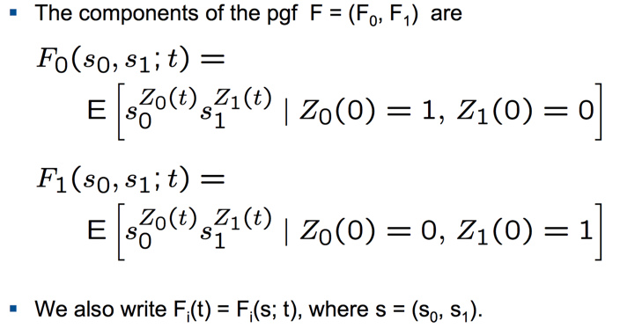

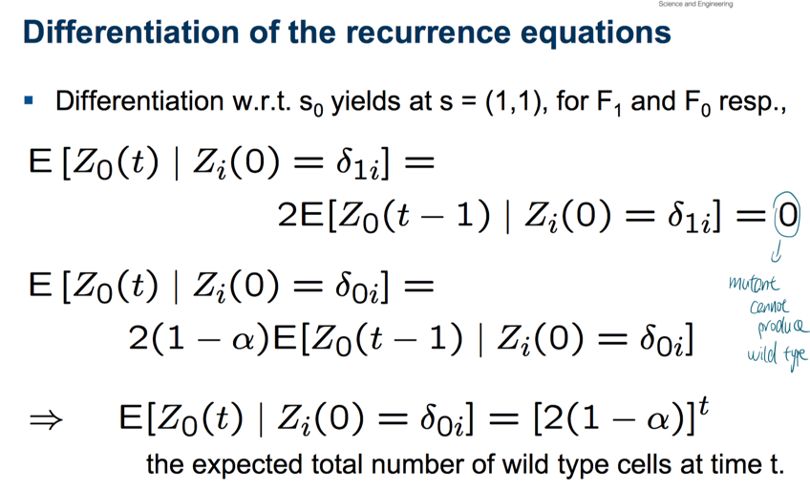

The number of cells at time t

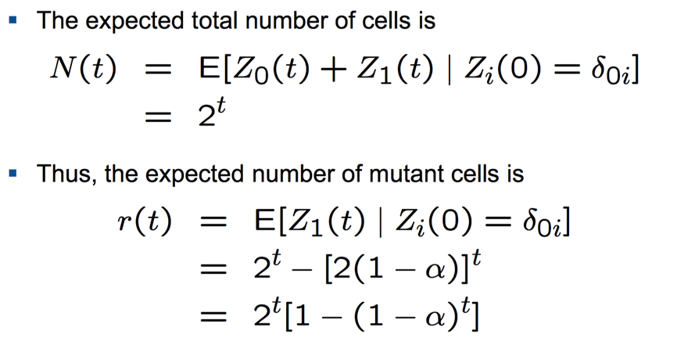

The probability of a mutant-free population

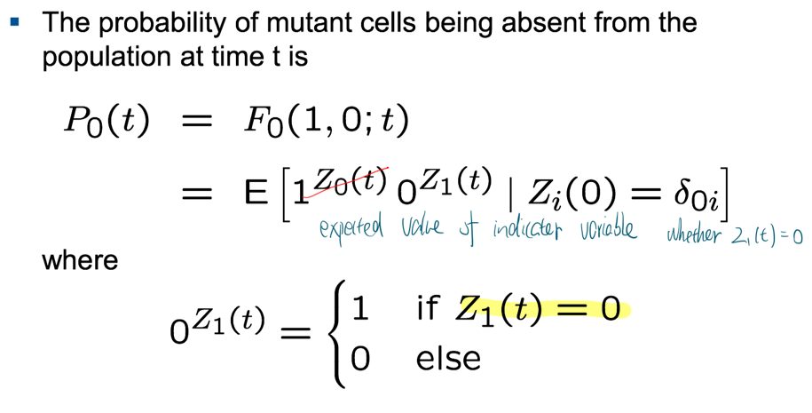

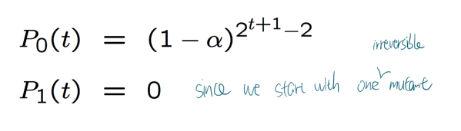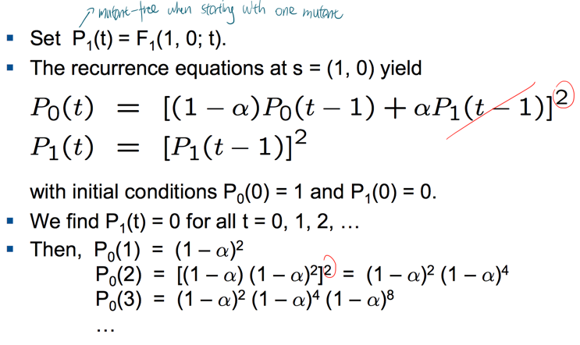 =>

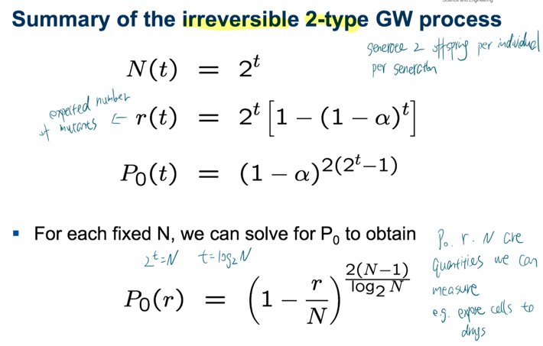

**Partially ordered sets $ε$** : we don’t know the order of all elements

**cover relation**: e 1 < e 2 is a cover relation, if there is no e’ with e 1 < e’ < e 2 .

**order ideal**: subset g in the poset $ε$ that is closed downward. E.g. if $e_{2}∈ g and e 1<e 2 , then e_{1}∈g$

**distributive lattice** J($ε$): set of all order ideals of $ε$

**The genotype lattice** : Let $ε$ be a set of n = | | irreversible genetic events. The poset encodes constraints on the order in which mutations can accumulate. The order ideals g of J($ε$) are the genotypes that can evolve subject to the order constraints. $G= J\left(ε\right)$ is the genotype lattice.

**Chain of length k**: collection of k totally ordered subsets. $g_{1}⊂g_{2}⊂…⊂g_{k}$. It actually represents the mutation pathways.

**Fitness landscapes**: a mapping f: $G→R$

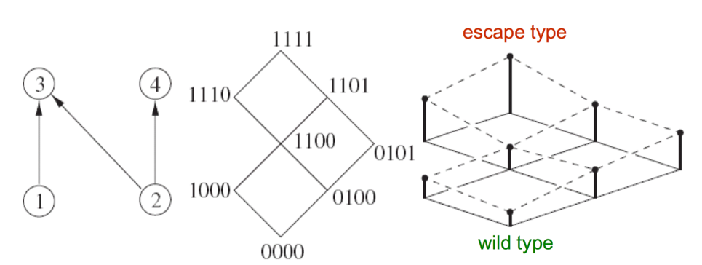

**Evolutionary escape**: the wildtype with lower fitness will extinct eventually. In order to escape extinction, it should be mutated fast to reach the escape state.

**Mutational neighborhood**: the set of genotypes h $∈$ G that can be reached by mutation. $N\left(g\right)=\left\{h∈G\right|g⊂h\}$

Assumption

1. 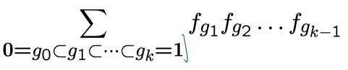Mutation: $μ_{e}$ is the mutation rate of event e $∈ϵ$. mutations are independent of each other.

**The risk polynomial**: $R\left(G;f\right)=P_{01}\left(f\right)=$

. It encodes the set of escape pathways in the genotype lattice.

**The basic reproductive ratio $R_{g}:$ $\frac{f_{g}}{1+f_{g}}$** if define $f_{g}=\frac{R_{g}}{1-R_{g}}=R_{g}+R_{g}^{2}+R_{g}^{3}+…$. Assume $R_{1}>1 and R_{g}<1 for g≠1$.

Consider a branching process on the type space G with a Poisson offspring distribution

$ρ_{gh}^{k}$ represents the probability that a single individual of type g produces k children of type h.

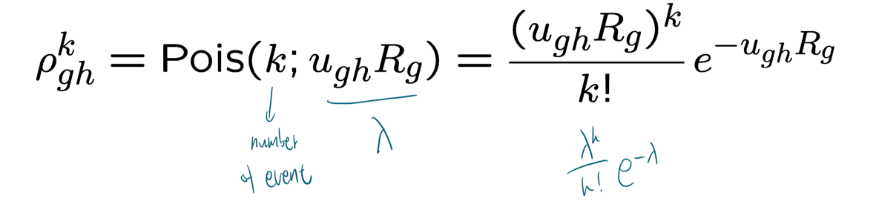

$ξ_{g}$ is the probability of escape (reaching 1 before extinction) starting with one individual of type g.

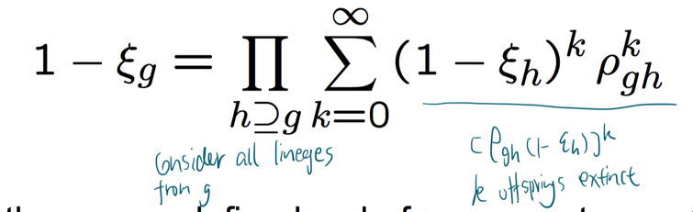

Substituting the Poisson distribution, simplifying, and taking logarithms, we find

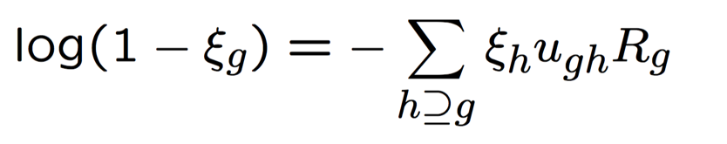

**Recurrence equations**

For $g≠1, ξ_{g}≪1 and {\left(R_{g}\right)}^{2}≈0$,

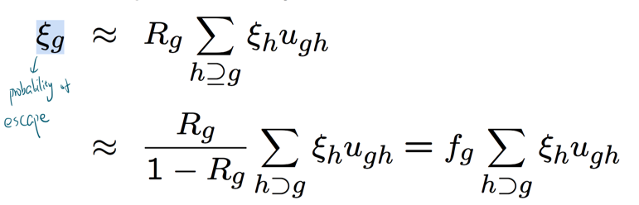

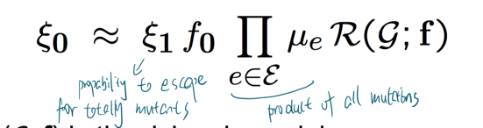

The risk of escape for N wild type pathogens is $1-{\left(1-ξ_{0}\right)}^{N}≈1-e^{-ξ_{0}N}$

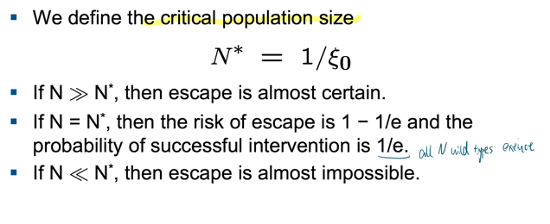

The critical population size

Example

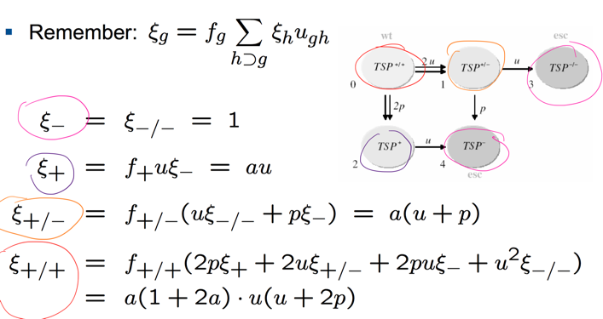

**The** **coalescent theory**

Coalescent events in **WF process**

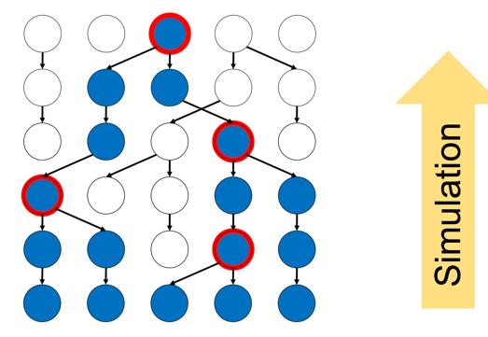

The probability that j genes have no common ancestor in the previous generation: $\prod_{i=1}^{j-1}{\left(1-\frac{i}{N}\right)}=1-\left({j \atop 2}\right)N^{-1}+O(N^{-2})$

**The coalescent time**

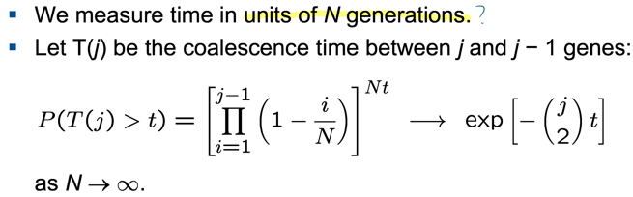

The coalescence time is distributed **exponentially with parameter (j choose 2)= $\frac{j\left(j-1\right)}{2}$**

**Time to the Most recent common ancestor (MRCA)**

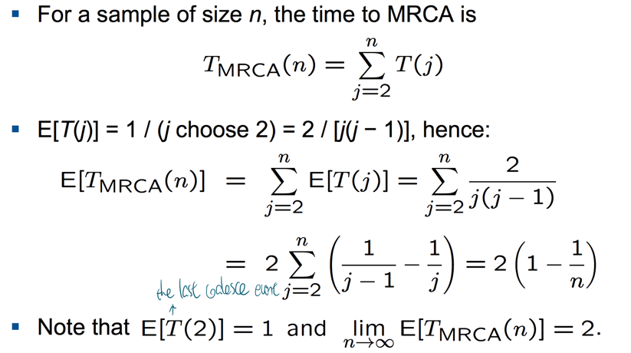

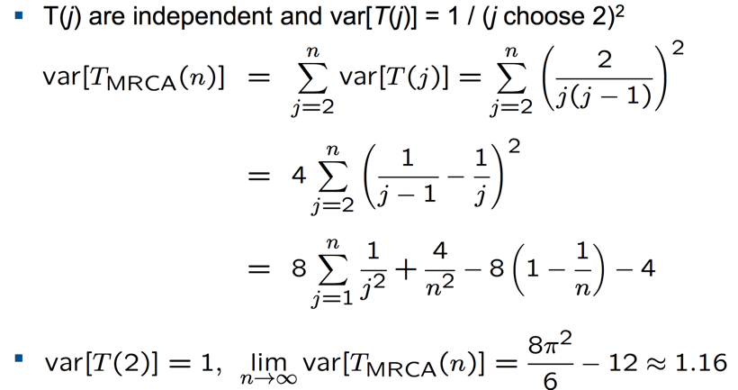

Therefore $T_{MRCA}(n)$ **is dominated by $T(2)$**

**Estimation of mutation rate**

**Assumption**

1. We assume **a Poisson process** that puts down mutations independently on all branches at rate $θ$/2, where $θ$ = 2 N u is the scaled mutation rate.
2. We assume an infinite number of sites (loci) and each mutation to affect a different nucleotide site. **The infinite sites model** is appropriate for long DNA sequences under **neutral evolution**.

**Number of segregating sites**, S: number of sites in the genome where lineages are segregated

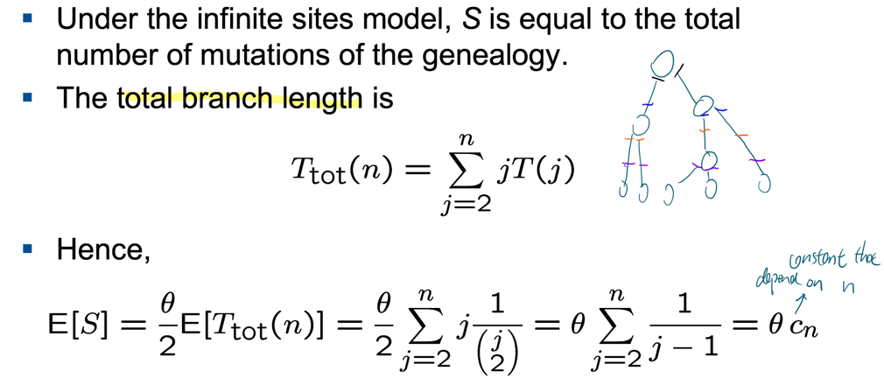

**For average pairwise nucleotide distance**, K, $E\left[K\right]=\frac{θ}{2}2E\left[T\left(2\right)\right]=θ$

Under the neutral infinite sites model, we have two different estimates of the mutation rate:

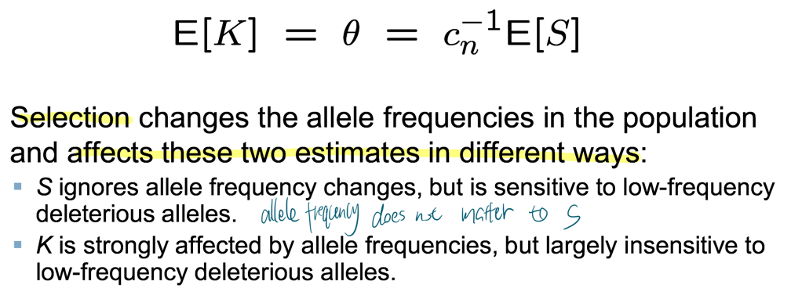

**detecting selection (deviation from neutrality)**

**Tajima’s D**

